Ohio Department of Transportation

e-Construction - Mobile Device Training

Verizon LG Gpad
July 6, 2016

Table of Contents

Section 1 LG Gpad Device overview PG 3

Section 2 Entering Daily Work Report (DWR) with InfoTech
Mobile Inspector PG 8

Section 3 Construction Inspection Forms PG 13

Section 4 Reference Information PG 16

APPENDIX Policies list and attached PG 20

SECTION 1 – LG Gpad Device Overview

Top 5 reasons to read the Get to Know Your Tablet guide provided for you with your device.

1 Charging your tablet PG 3
2 Review of Tablet Features PG 4 & 5
3 Turning tablet on / off PG 6
4 Locking / Unlocking your tablet PG 7
5 Connecting to Wi-Fi PG 8

Included with your device

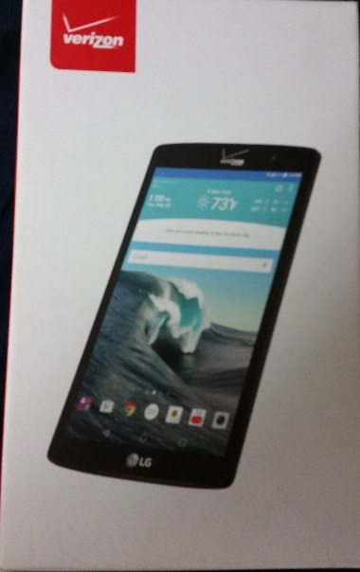
YOUR LG Gpad X 8.3

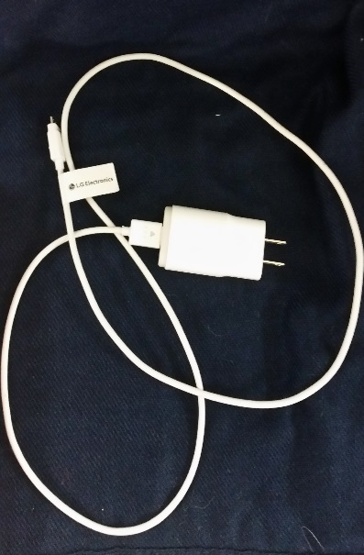

Device box with all contents including the Get to Know Your Tablet pamphlet

USB cord and travel adapter for charging

Mobile Applications to install to your device

Cisco AnyConnect
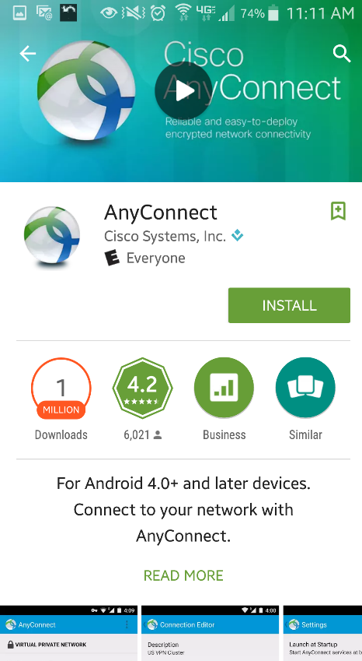
CM Flashlight
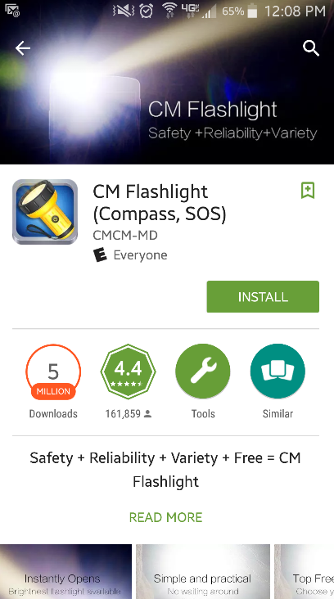
Concrete and Aggregate Calculator
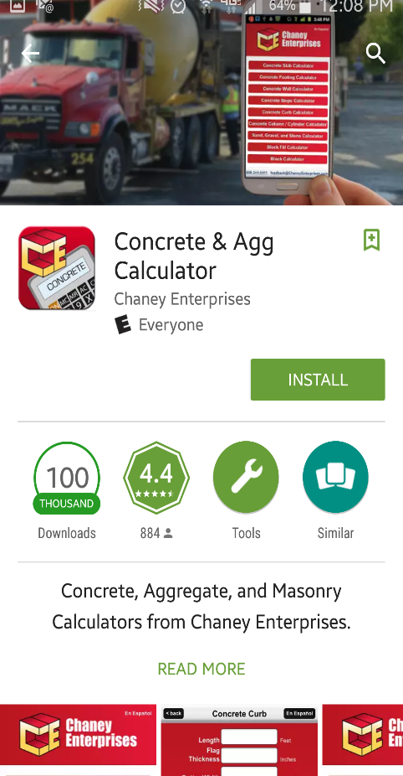

DUO Mobile - * This app needs to be installed to a separate device
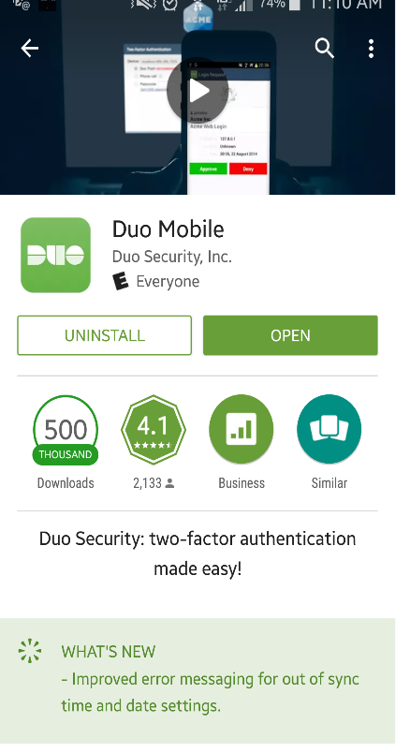
Info Tech Mobile Inspector
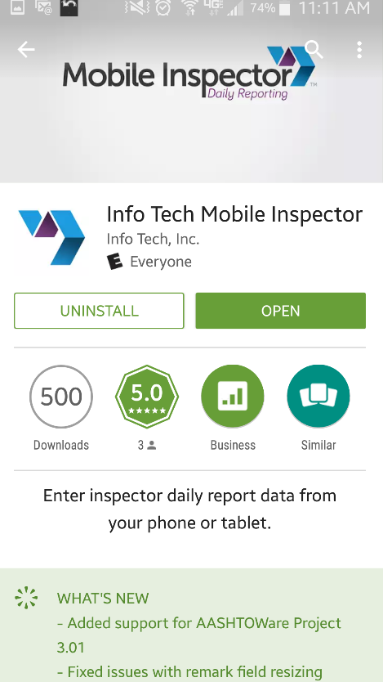
Office Lens
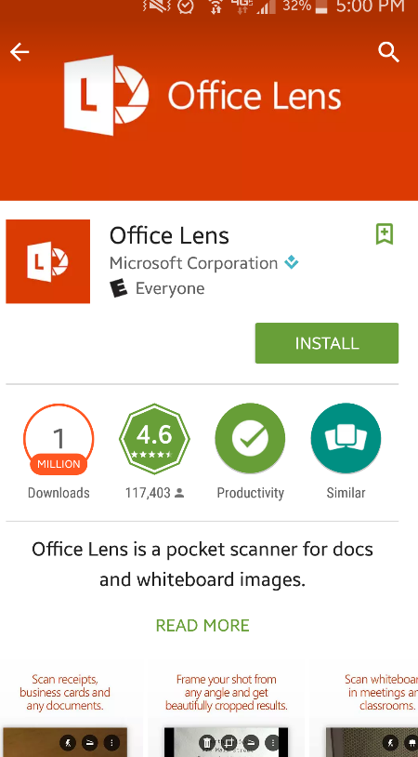

The Weather Channel

VMWare Horizon Client
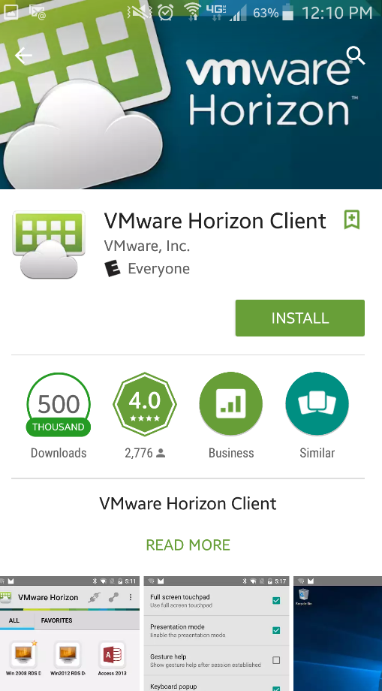
SECTION 2 – Entering Daily Work Reports (DWR) with Mobile Inspector
The InfoTech Mobile Inspector application will allow you to complete a DWR with limited or no connectivity at all. You can just work on the report all day and when you have completed the entry and confirmed that the information is correct you will “lock” the DWR and the information will “sync” or upload to the SiteManager automatically. This is done utilizing a bridge service so it cycles on a five (5) minute interval to look for new information to pull or to push new contract(s) or contract information to the device.

Select the Mobile Inspector App from your device
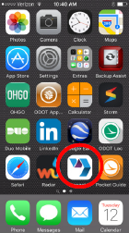

The project(s) that are available show up on the screen. Select the “+” sign to open the project
By default, the app opens to the current date and on the “Details” tab. If you are entering a diary for a different date you can select the date field and change the date.

Enter the AM weather conditions, PM weather conditions, high temp and low temp. Next, select the remarks field.

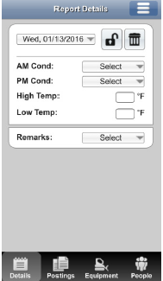

When the remarks field is selected the following remark categories are shown. Select general remarks for the bulk of the diary information such as the description of the contractor’s work, etc. Select equipment to enter the contractor’s equipment for the day.

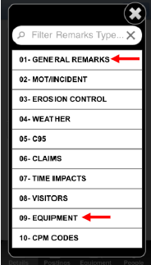

Once a remarks category is selected you may type the information using the touch keypad on the LG Gpad or you can select the microphone to perform the “talk to text” feature. You may use a combination of “talk to text” and typed text. If multiple contractors are working the name of each contractor is required to be typed before entering information that pertains to that contractor.

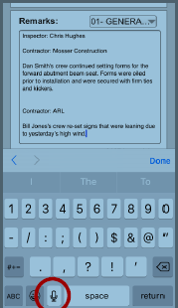

Once the contractor data is complete it is time to enter the pay items. Select the “Postings” tab at the bottom to enter pay items. The item can be selected from the drop down menu. On the contractor menu, always select the contractor that is performing the work. The location (plan page, bubble number, station, mile mark, bridge number, etc.) is entered next. The remaining fields are left blank. When the pay item is complete select the checkmark at the bottom of the page.
You can now use the Remarks section in the Postings tab to provide additional and detailed information. The “talk to text” functionality to complete this.
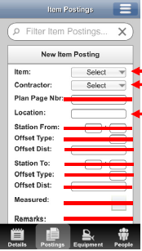
Do not use the Equipment tab at the bottom of the screen

Click the People tab and select either Personnel, Agency Staff, or Supervisors.
Personnel is for the contractor’s laborers and skilled workers.
Agency Staff is for the ODOT inspector.
Supervisors is for the contractor’s superintendent or foreman
.
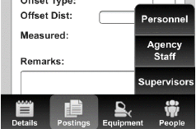

Example of selecting Personnel
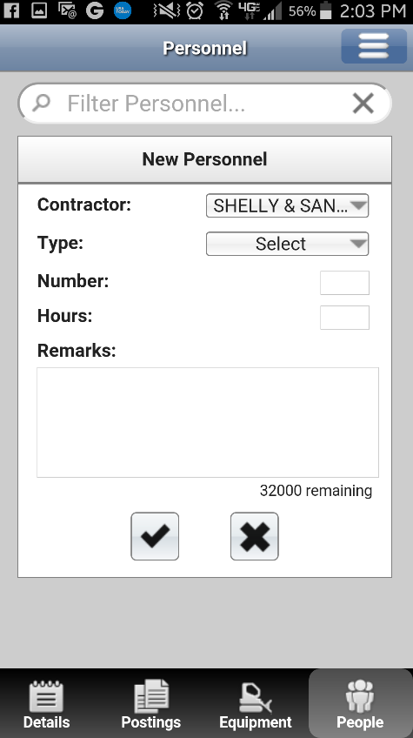

Click the check box to save and move to the next type of People entry.

Once the DWR is complete, go back to the details tab and select the lock icon at the top. When the lock icon is selected the DWR is locked so only do this when you are completely done with the DWR. If you need to modify a locked diary you will have to get into SiteManager to do so. * Please remember the 5 minute cycle to sync into the SiteManager system. Do not forget to lock the diary when you are done because an unlocked diary will not show up in SiteManager for the Engineer to approve.

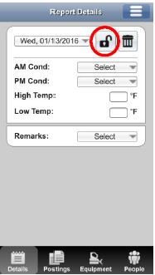

Section 3 – Construction Inspection forms

All construction inspection forms have been converted to electronic format so that they can be filled out using the tablet. The goal is for all forms to be completed and turned in electronically.

Construction Inspection forms can be located on the Construction Reference Resource Center (CRRC) http://www.dot.state.oh.us/crrc/Pages/default.aspx# or directly at the following link.

http://www.dot.state.oh.us/Divisions/ConstructionMgt/admin/pages/inspectionforms.aspx

Upon selecting the required form to complete a pop up box should appear requesting which app to open to complete the process. Select the ThinkFree Office application.

Until we have Office 365 completely deployed to all DOT employees the Microsoft Excel app will not function correctly on your device.

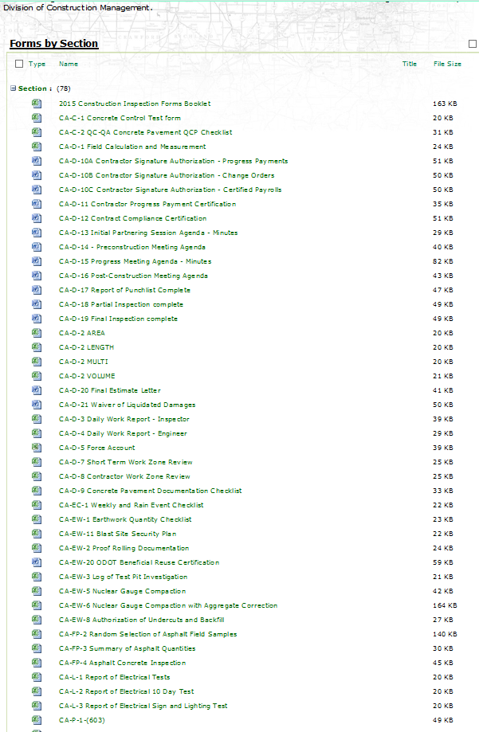

After you have selected the form and opened it with ThinkFree Office you can complete the data entry utilizing the stylus /keyboard functionality. By double clicking in a desired cell the keyboard will appear at the bottom of the screen.

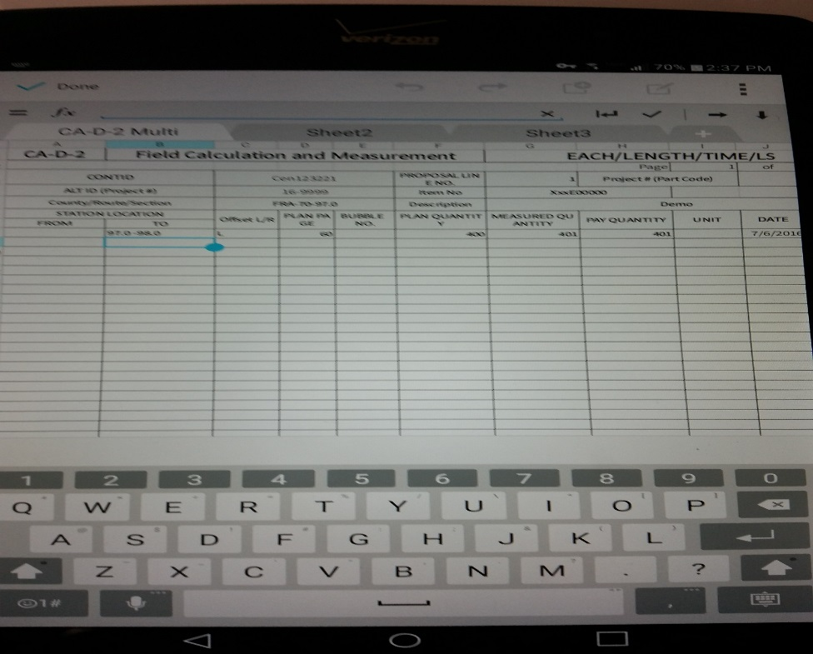

When you have completed the form you can choose to save the form, save as a pdf, or share the form via your email.

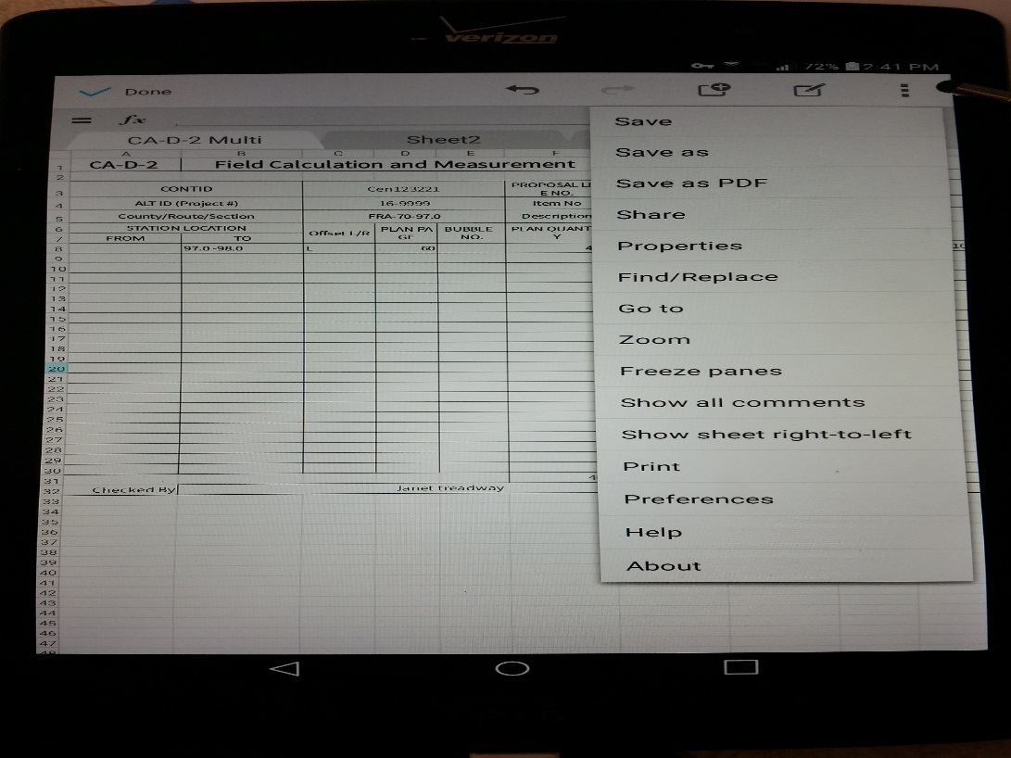
When we have upgraded to the Office 365 availability you will be able to do much more with your Excel form including adding photos and drawings. Drawings can be used in conjunction with text entered into the cells to show dimensions and calculations. Various shapes, lines, arrows, etc. are available that can be combined to create more complex drawings. The colors, line weights, fill patterns, etc. can also be modified as needed.

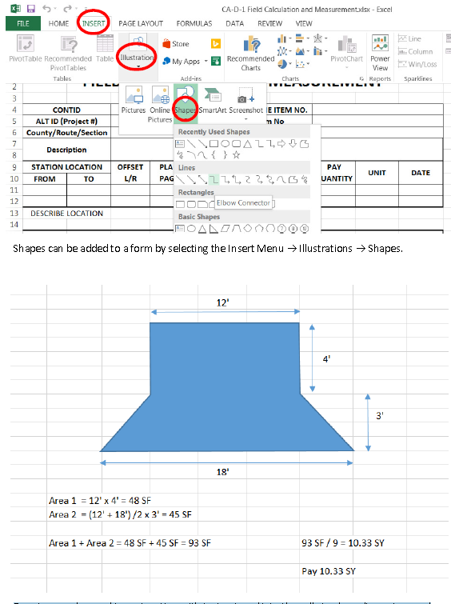
Section 4 – Reference Information

Construction Reference Resource Center (CRRC):
The Construction Reference Resource Center (CRRC) is an ODOT website that contains links to most useful reference sites, documents, and other resources that are used on ODOT construction projects.
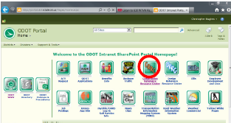
From the ODOT intranet homepage click on the CRRC link
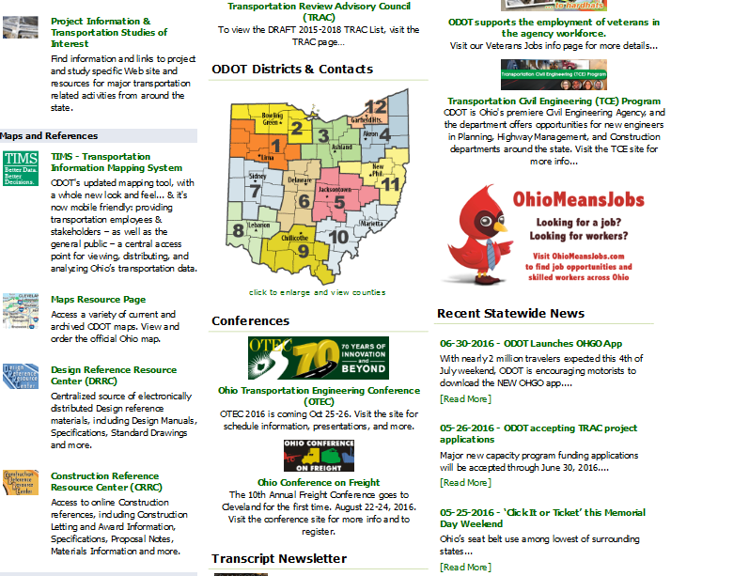
From the Ohio.gov internet webpage click on the CRRC link
The CRRC is organized alphabetically. Some information that may be useful in the field includes but is not limited to the following:

Approved Asphalt FQCS – A listing of Asphalt Field Quality Supervisors
Approved Field Welders
Approved Material List – A listing of approved materials for certain material types
CMS Portal – See next section
Construction Administration Manual of Procedures (MOP)
Ohio Manual of Uniform Traffic Control Devices (OMUTCD)
Qualified Products List (QPL)
Road Viewer Program – Historical photos of State Rotues
SiteManager Quick Guides
Standard Drawings
Supplemental Specifications/Supplements
Virtual Warehouse (TE-24)

CMRS Portal (SiteManager Construction Management Reporting System)
The CMS Portal is a tool that takes data from SiteManager to generate a variety of reports for specific projects. To access the CMRS Portal use the link on the CRRC.

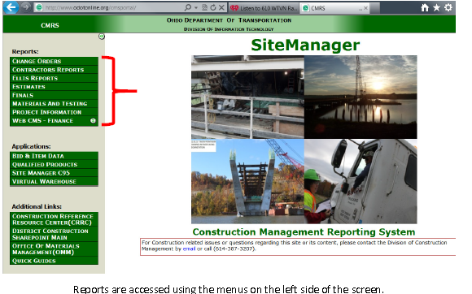
Estimates Tab
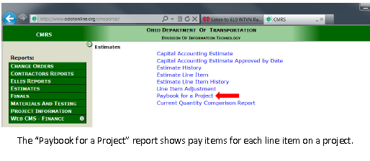
Materials and Testing Tab
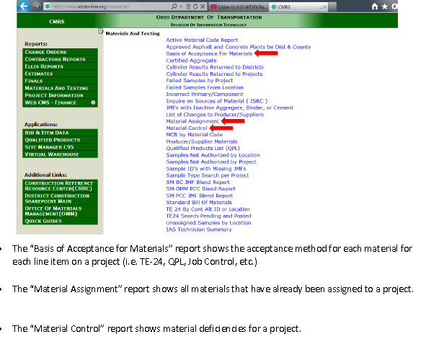
Project Information tab
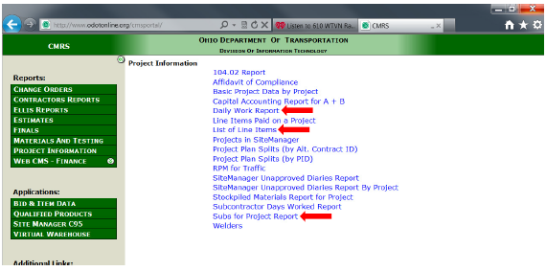
- The “Daily Work Report” contains information entered into the daily diary in SiteManager or Mobile Inspector.

- The “List of Line Items” report contains all the line items on a project including unit prices. This report does not include what has been paid on each item.

- The “Subs for Project Report” includes a list of subcontractors approved to work on designated items for a project

APPENDIX
ODOT Mobile Device User Agreement
DAS - State of Ohio IT Policy as of 05/25/15
ODOT Policy 28-019(P) Electronic Signatures

