Virtual Warehouse Produce/Supplier Manual

**About Virtual Warehouse**

Virtual Warehouse is the electronic documentation method for materials that have been sampled, tested, approved, and stocked for future use on ODOT projects.

Virtual Warehouse is not intended to be used to individually approve unique or special materials for each project as you receive the orders. If your company is unable to stock large quantities of material, Virtual Warehouse may not benefit you. Virtual Warehouse is also used to document shipment of materials from a company in one of Ohio Department of Transportation (ODOT) Certification Programs. Virtual Warehouse is also used to ship steel and prestressed bridge beams that are inspected at the plant.

You must comply with ODOT's specifications that govern the type of material your company produces or supplies. You must also be approved by the Office of Materials Management (OMM) to ship materials.

If you are accepted for Virtual Warehouse use and are located more than 50 miles outside of Ohio, you may be required to use an independent laboratory for sampling inspection at your own expense. The independent lab must provide a letter with each inspection documenting the date of inspection, signature of the inspector, and a list of all materials and quantities represented. Any appropriate certifications and/or proof of domestic origin should be attached.

**Required Paperwork**

AT A MINIMUM, a copy of any shipment of materials you create in Virtual Warehouse (TE-24) must accompany each and every shipment. The driver of the truck must have a printed copy to present to the project engineer (PE) on site. If you have multiple trucks going to the same location on the same day, one form may cover all of the shipments and be given to the first driver. Any shipments that are sent out on a separate day must have a separate form.

For companies shipping materials under an Ohio Department of Transportation (ODOT) Certification Program the certification program may require additional documentation, such as an inventory of bill of lading, further breaking down the material item shipped. If you are certified, you are responsible for complying with that additional documentation for each shipment.

You may create the paperwork in advance using the create shipment feature. The form reflects the date the paperwork is completed and NOT the actual date of shipment. This is permissible. A hard copy of all shipments must be kept by the producer/supplier’s (P/S) office in their filing system.

**Objectives of the System**

The primary objectives of the Virtual Warehouse system are to:

1. Provide information about project materials.

2. Allow shipment of materials to project sites and provide electronic documentation.

3. Allow shipment of materials to other producers or suppliers (P/S) and electronically document those shipments. (Transfer)

4. Allow shipment of materials to a Local Project Assistance (LPA) project and provide documentation.

5. Allow shipment of materials to non-state projects and provide documentation.

6. Provide a method of inventory and control for ODOT acceptable materials

**Link to Virtual Warehouse**

<http://www.odotonline.org/cmsportal/>

Help Email

[Virtual.Warehouse.Help@dot.state.oh.us](mailto:Virtual.Warehouse.Help@dot.state.oh.us)

**Link and instruction on how to create primary user account using MYODOT**

<https://myodot.dot.state.oh.us/>

**Logging into Virtual Warehouse**

When you open the CMRS Portal, the navigation pane in the left frame allows you to select where you want to log in. In order to use Virtual Warehouse, you must open the application link and login using your Username and Password.

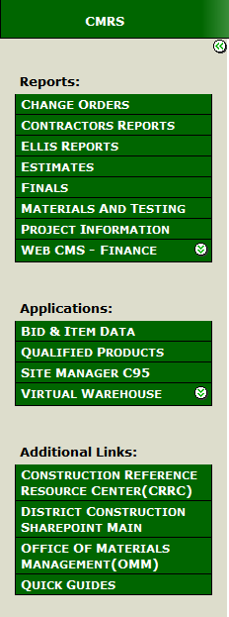

Press the Virtual Warehouse  button. The Virtual Warehouse login screen opens.

Virtual Warehouse Login Screen

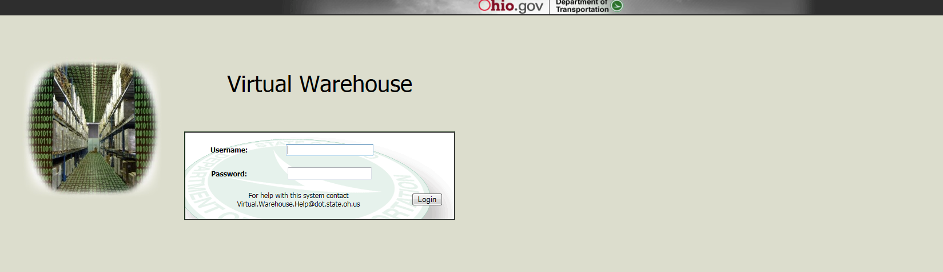

Type in your MYODOT username and password to access Virtual Warehouse. To create MYODOT account follow the link below.

<https://myodot.dot.state.oh.us/>

Primary user can create secondary account for another users.

Once you are login you will see the following screen.

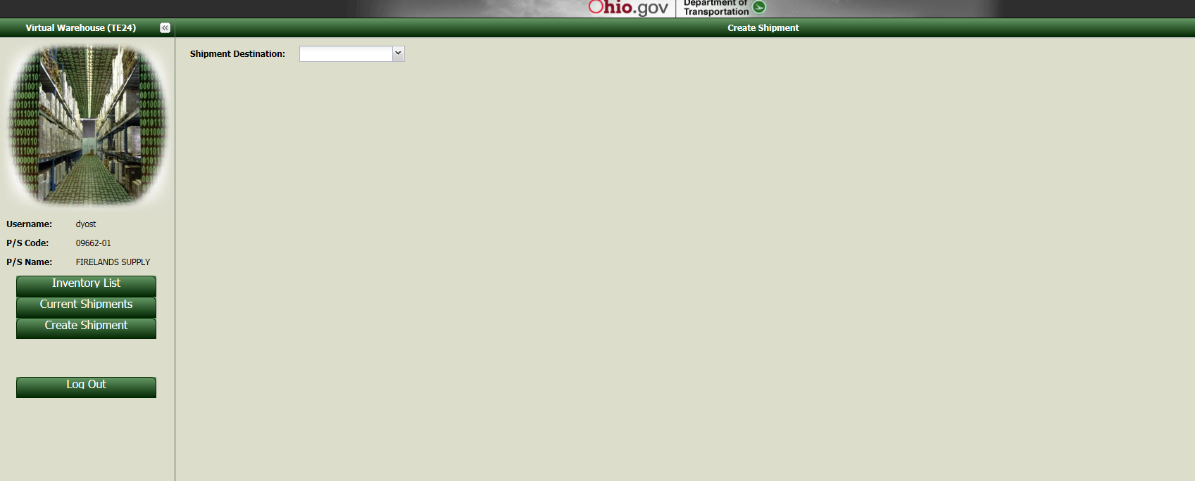

The left navigation frame indicates that you are logged in and the list of Virtual Warehouse functionality options display. Click on the link in this table to choose the option you want.

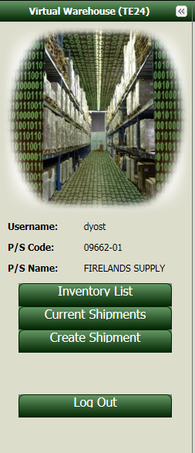

|  |  |
| --- | --- |
| Option | Description |
| Inventory List | A list of the inventory you currently have in the system for this account. This list includes inventory samples for samples for the SITEMANAGERsystem |
| Current Shipment | A list of the Site Manager shipments pending in the system to ODOT or to another TE-24 supplier. After ODOT approves the shipment, the shipment disappears from this list. Shipments to other P/S or locations are not approved by ODOT.  The list also can include shipments to ODOT projects using the SITEMANAGER system. Shipments to a SITEMANAGER project are removed from the Current Shipments list after they are authorized. They are available for viewing and editing for the first 72hrs if not authorized. After 72hrs if still not authorized, they can only be viewed.  Transfers of SITEMANAGER materials or TE24 written to LPA’s, Others, inventory also are authorized after 72hrs and disappear from the Current Shipments |
| Create Shipment | Create the shipment of materials in this section. This is the default screen (you have option to pick Producer Supplier, Project, LPA or other) |
| Log Out | Exit the Virtual Warehouse |

In Shipment destination screen you can pick Producer Supplier, Project, LPA or other. If you pick Producer Suppler the drop down will display list of all the producers. You can pick one. In LPA or Other you need to fill the box.

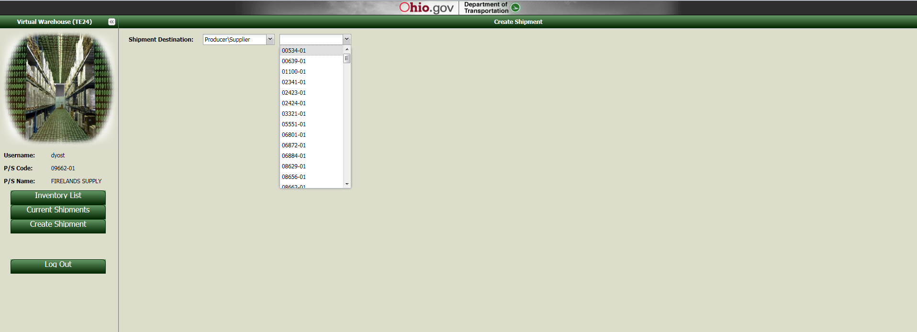

Once you pick the Producer your next screen you can pick the sample id by clicking on sample id drop down box than you can choose quantity to be shipped the next tab is to write your comments and available quantity for the sample ID. To add next row you can click on add row. Similar steps are for LPA and other shipment.

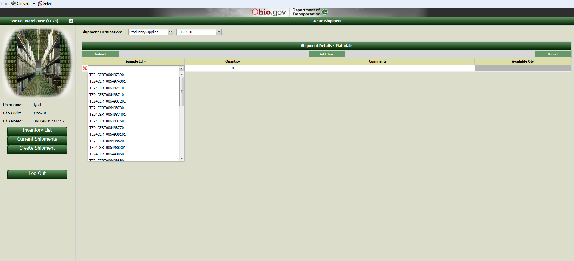

Once TE24 is complete you can click on Submit .You will be able to see the PDF format of your TE24 and can print.

