Monthly Employment Report (Form: FHWA-1589-modified)
Format: Reporting entities will be ODOT, prime contractors, Local Public Agencies (LPA), railroads and prime consultants. Each reporting entity will be required to obtain a user id and password in order to authenticate the data received. To request a user id fill out the Account Request Form located at
http://www.dot.state.oh.us/Divisions/ContractAdmin/Contracts/Pages/AccountRequest.aspx
Due date: Submissions are due by the Local Public Agency (LPA), prime contractor, railroads and prime consultant by the 10th of each month. Contractors and consultants will start reporting at which time they have a signed agreement/contract.

Coding Instructions – Section 1

Section 1 identifies the user doing the reporting on a given project. Username, email address and contractor name will be automatically populated on login to the site. Users will be required to enter the DUNS number and report month.

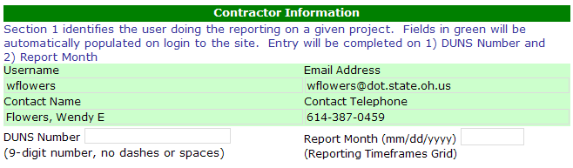
Report Month: Enter the month and year covered by the report, as mm/yyyy. (e.g. “May 2009” would be coded as “05/2009”).

DUNS number: The unique nine-digit number issued by Dun & Bradstreet. Followed by the optional 4 digit DUNS Plus number. Reported as “999999999.9999”. All reporting entities are required to obtain a DUNS number if one is not already assigned. To obtain a DUNS number please go to:

https://eupdate.dnb.com/requestoptions.asp

If the reporting entity has multiple DUNS numbers, they are are to use the same DUNS number on all projects.

Coding Instructions – Section 2

Section 2 identifies the project being reported.

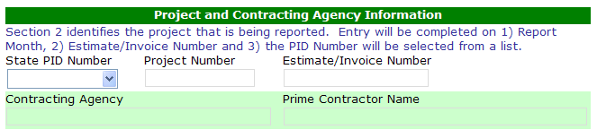
State PID Number: Select the PID reporting on from the list.
Project Number: Enter the Project Number
Estimate/Invoice Number: Enter the corresponding estimate or invoice number of the estimate or invoice being turned in for that reporting period.
Contracting agency: Auto-populated with the name of the contracting agency. It will be “State” for State DOT projects. For non-State projects, populated will be the name of the contracting agency (other State agency, Federal agency, tribe, MPO, city, county, or other funding recipient).
Prime Contractor Name: Auto-populated with the name of the prime entity reporting

Coding Instructions Section 3 – Employment data
The LPA, railroad, prime contractor or consultant will report the direct, on-the-project jobs for their workforce and the workforce of their sub-contractors or sub-consultants active during the reporting month. These jobs data include employees actively engaged in projects who work on the jobsite, in the project office, in the home office or telework from a home or other alternative office location. This also includes any engineering personnel, inspectors, sampling and testing technicians, and lab technicians performing work directly in support of the Recovery Act funded project. This does not include material suppliers such as steel, culverts, guardrail, and tool suppliers.
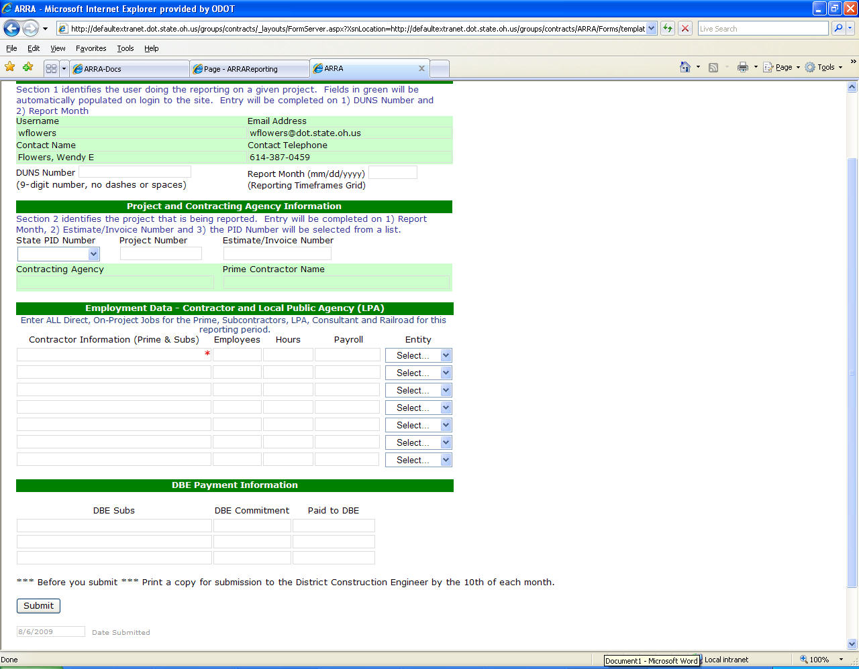
Contractor Information: Fill in the name of the LPA, Prime Contractor, Railroad, each subcontractor or sub-consultant that was active on the project for the reporting month. Only one per line.
Employees: The number of project employees on the workforce that month for the entity listed in the contractor information field. Do not include material suppliers. Total field at bottom will be automatically calculated and reported as a whole number.
Hours: The total hours on the specified project for all employees reported for the entity listed in contractor information field on their project workforce that month. Total field at bottom will be automatically calculated and reported as a whole number.
Payroll: The total dollar amount of wages paid by the entity listed in the contractor information field that month for their employees on the specified project. Payroll only includes wages and does not included overhead or indirect costs. Total field at bottom will be automatically calculated and will be rounded to the nearest whole dollar and reported as a whole number.
Entity: Select the type of entity listed in the Contractor Information field
Coding Instructions – Section 4 DBE Payment Information

DBE Subs: List any subcontractors on the project which are DBE
DBE Commitment: The dollars committed to be paid to DBE subcontractors at the time of bid
Paid to DBE: The total dollars paid to the DBE in the reporting month

Once all sections are filled out, print a copy and give to the district DCE and then click submit.

