Curb Ramp Evaluation Form Common Curb Ramp Layouts
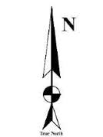
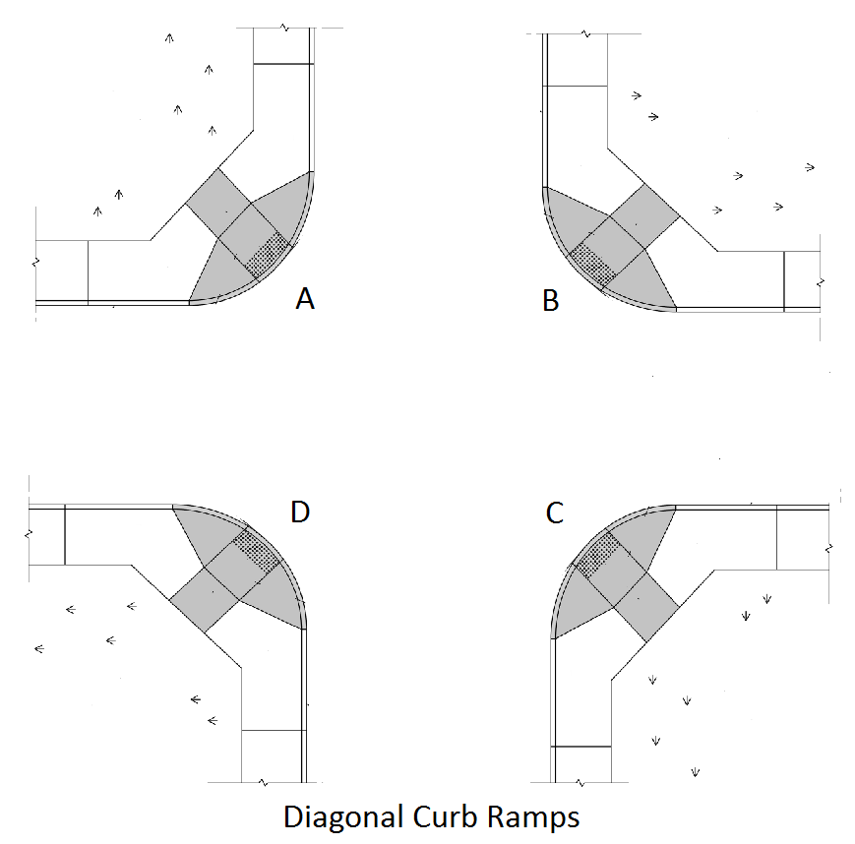
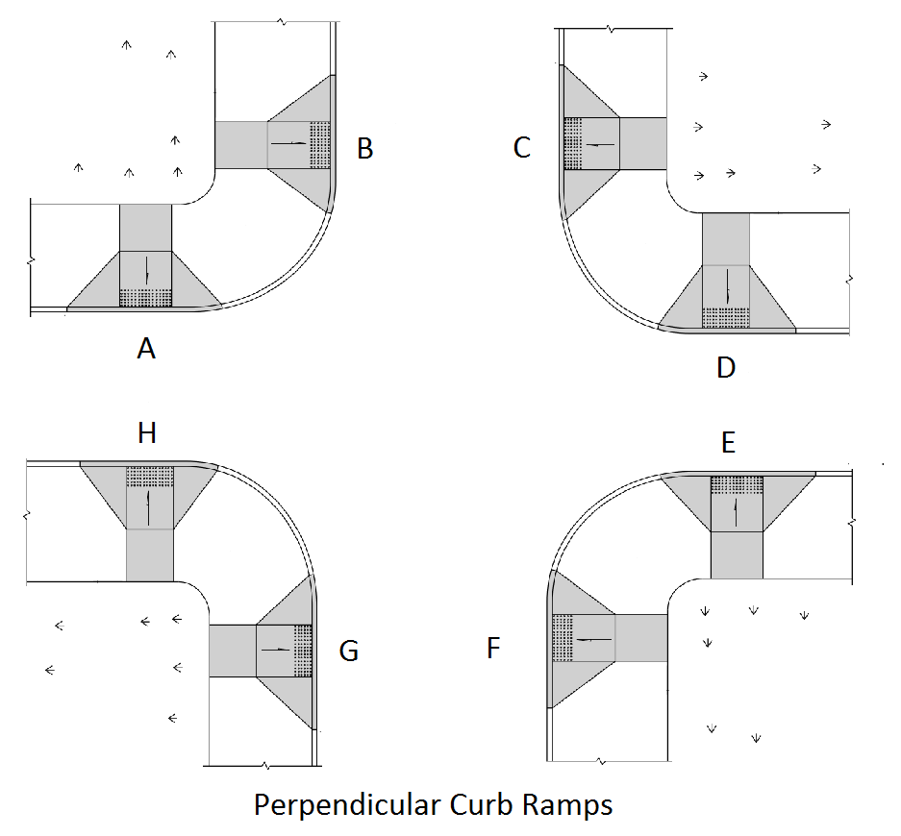
Intersection Location: | Date:
 | Surveyors / Reviewer:

Describe each curb ramp’s location (If not a common layout, attach a sketch of the intersection and describe below):
Curb Ramp A: | Curb Ramp E:
Curb Ramp B: | Curb Ramp F:
Curb Ramp C: | Curb Ramp G:
Curb Ramp D: | Curb Ramp H:

Refer to # | Curb Ramp (CR) Questions | Curb Ramp A |  | Curb Ramp B |  | Curb Ramp C |  | Curb Ramp D |  | Curb Ramp E |  |  | Curb Ramp F |  | Curb Ramp G |  | Curb Ramp H
1 | Is ramp of CR at least 36” wide (not including flared sides)? (A) | Y | N | Y | N | Y | N | Y | N | Y |  | N | Y | N | Y | N | Y | N
2 | Does ramp of CR have a running slope of 8.33% or less? (B) | Y | N | Y | N | Y | N | Y | N | Y |  | N | Y | N | Y | N | Y | N
 |  | % |  | % |  | % |  | % |  | % |  |  | % |  | % |  | %
3 | Does CR have a cross slope of 2% or less? (C) | Y | N | Y | N | Y | N | Y | N | Y |  | N | Y | N | Y | N | Y | N
 |  | % |  | % |  | % |  | % |  | % |  |  | % |  | % |  | %
4 | Does CR have a gutter slope of 5% or less? (D) | Y | N | Y | N | Y | N | Y | N | Y |  | N | Y | N | Y | N | Y | N
 |  | % |  | % |  | % |  | % |  | % |  |  | % |  | % |  | %
5 | Are transitions on and off CR flush and free of abrupt level changes (Algebraic difference between Ref. #2 and Ref. 4, less than 11%)? (E) | Y | N | Y | N | Y | N | Y | N | Y | N |  | Y | N | Y | N | Y | N
 |  | % |  | % |  | % |  | % |  | % |  |  | % |  | % |  | %
6 | Does CR have detectable warnings? (not required if constructed during suspended period – see note #6) (F) | Y | N | Y | N | Y | N | Y | N | Y |  | N | Y | N | Y | N | Y | N
7 | Is the landing at the “top” of CR at least 36” wide? (1991 ADA specification) (G) | Y | N | Y | N | Y | N | Y | N | Y |  | N | Y | N | Y | N | Y | N
8 | Does CR have flared sides? If yes, answer one of the next two questions. If not, skip to question 11. (H) | Y | N | Y | N | Y | N | Y | N | Y |  | N | Y | N | Y | N | Y | N
9 | If the sidewalk at the “top” of CR is 48” wide or more, is the slope of the flared sides 10% or less? (I) | Y | N | Y | N | Y | N | Y | N | Y |  | N | Y | N | Y | N | Y | N
 |  | % |  | % |  | % |  | % |  | % |  |  | % |  | % |  | %
10 | If the sidewalk at the “top” of CR is less than 48” wide, is the slope of the flared sides 8.33% or less? (J) | Y | N | Y | N | Y | N | Y | N | Y |  | N | Y | N | Y | N | Y | N
 |  | % |  | % |  | % |  | % |  | % |  |  | % |  | % |  | %
11 | If no flared sides, is there an obstruction or grass on each side of CR that discourages pedestrians from traveling across ramp? If the CR has flared sides, skip this question. (K) | Y | N | Y | N | Y | N | Y | N | Y |  | N | Y | N | Y | N | Y | N
12 | If diagonal-type CR, is bottom landing at least 48” long and contained in crosswalk? If not diagonal-type CR, skip this question. (L) | Y | N | Y | N | Y | N | Y | N | Y |  | N | Y | N | Y | N | Y | N

Notes:
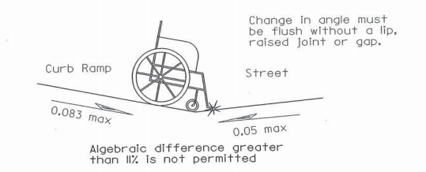
(A) 1991 ADA requirements include a 36” minimum ramp width. The Ohio Revised Code requires a 40” width. Figure 1 shows the current ODOT
standard of 48”

(B) The maximum running slope of the ramp is 8.33% or 12:1 as shown in Figure 1
(C) The maximum cross slope of a curb ramp and sidewalk is 2%.
(D) The maximum gutter slope is 5% as shown in Figure 3.
(E) See Figure 3
Figure 3
(F) Detectable warnings are required unless the curb ramp was constructed during the period of time when they were suspended. (May 12, 1994 to July 26,
1998 or December 23, 1998 and July 26, 2001).

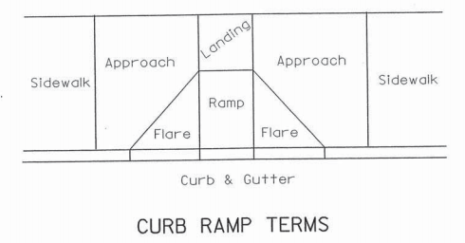
(G) 1991 ADA requirements for the landing adjacent to a curb ramp with flared sides is a minimum of 36”. The current ODOT standard is 48”
minimum with 60” preferred.

(H) See Figure 4 for ramp terms
(I) If the landing is 48” or wider, the maximum slope of the curb ramp flared side is 10:1.
(J) If the landing is less than 48”, the maximum slope of the curb ramp flared side is 12:1
(K) If there are no flared sides, the landing is required to be 48” wide. See Figure 2
(L) The use of diagonal curb ramps is only allowed for existing walks, and when site constraints prohibit other designs. See Figure 5

Figure 4
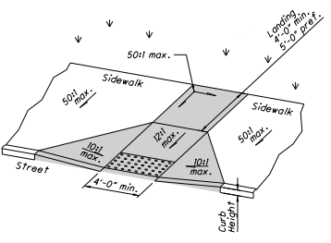
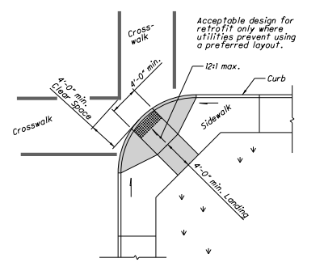
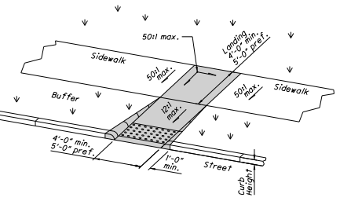
Figure 5
Figure 2
Figure 1

