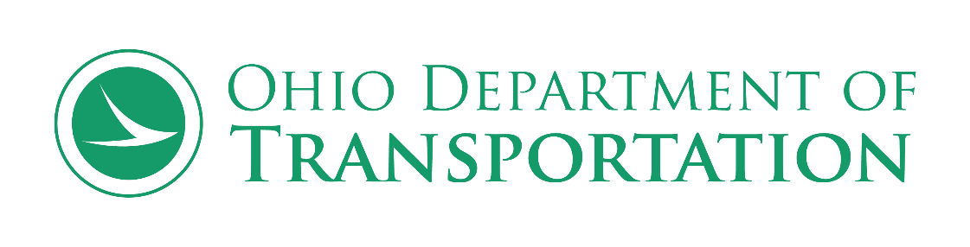

Local-Let – Guidance for LPA’s
DBE Utilization and Affirmation Procedure

This procedure is being released to assist the Local Public Agency (LPA) to ensure the DBE Policy is being adhered to. Timelines are critical to meet the regulations. These instructions must be followed to ensure all parties involved follow the correct process.

Prior to Bid Opening

Once federal authorization has been provided to the Local Program Agency (LPA), the LPA must complete the Bid Opening Date Form online.

If there is a change in the bid opening date, the LPA is responsible to resubmit the Bid Opening Date Form as soon as the new date is known.

Letting Process

Note: All documentation below must be submitted electronically. It is imperative that the LPA and Contractor follow this process.

Prior to bid opening, all Local-Let Bidders (prime contractors) are required to submit the LPA DBE Utilization Form which details their DBE Utilization Plan (Utilization Plan).

- The contractor’s LPA DBE Utilization Form in FormStack should list each DBE firm and contract dollar amount to be utilized by the contractor towards the project’s DBE goal.
  - In the case there is going to be a DBE goal shortfall at bid opening, Good Faith Efforts (GFEs) must be submitted by the prime contractor using ODOT’s Contractor's Good Faith Efforts (GFEs) Guidelines along with submitting its Utilization Plan via FormStack.
  - GFEs must be submitted to the ODOT Contracts Letting Manager by email to DOT.ContractsLettingMgr@dot.ohio.gov prior to bid opening.

- The LPA must notify the ODOT Contracts Letting Manager the same day of the bid opening as to the contractor that was the Apparent Low Bidder (ALB), the bid dollar amount to be awarded, and time of bid opening using the following email address: DOT.ContractsLettingMgr@dot.ohio.gov

- The Office of Small and Disadvantaged Business Enterprise (OSDBE) will inform the LPA by email if the Utilization Plan for the ALB submitted is approved. OSDBE will notify the LPA within 24 hours on the status of the pending approval. OSDBE will notify the LPA within 24 hours on the status of the pending approval.

Note: OSDBE will also copy the ODOT Office of Local Programs, District CCO and LPA Manager

- Once the LPA receives the Utilization Plan Approval from OSDBE, the LPA must notify the ALB immediately that the Utilization Plan is approved. The LPA must also request the ALB submit DBE Affirmation Forms (Affirmation Form) within five (5) calendar days of the date of the bid opening.

- The ALB must submit Affirmation Forms for all DBEs included in its Utilization Plan within five (5) calendar days of the bid opening to the ODOT Letting Manager’s email address: DOT.ContractsLettingMgr@dot.ohio.gov

- When emailing the Affirmation Forms, please include the PID in the subject line. It is important to have the Affirmation Forms emailed to the Letting Manager to ensure ODOT receives them within the timeframe required (five (5) calendar days from bid opening).

- If Affirmation Forms are not completed and received within five (5) calendar days of the bid opening, the ALB will be considered non-responsive.

- OSDBE will review the submitted Affirmation Forms and compare to the Utilization Plan submitted. OSDBE’s typical turnaround time for reviewing the Affirmation Forms is approximately 24 hours. The process may take longer if OSDBE identifies discrepancies, however, OSDBE will communicate and work directly with the ALB to address any issues or concerns on the Affirmation Forms, if identified. The LPA will be copied on all correspondence between OSDBE and the ALB.

- Once the Affirmation Forms are approved, OSDBE will send email communication notifying the ALB of its Utilization Plan approval. OSDBE will copy the LPA, the ODOT Office of Local Programs and the District CCO and LPA Manager. Awards cannot be completed without an approved Utilization Plan.

- After the award package is completed, and the encumbrance has been set up in ODOT’s accounting system, the LPA can execute the contract. Work may begin for non-DBE subcontractors. For DBE sub-contractors, work may not begin until C-92s are approved (see process below).

Approval Process C-92s (Request to Sublet Form)

- For DBE sub-contract work, the prime contractor must submit C-92s (Request to Sublet Forms) to the LPA. The LPA will review and provide an initial approval and signature to the District Contractor Compliance Officer (CCO) for final approval. The LPA will copy the District LPA Manager and Construction Monitor.

- The prime contractor will submit executed Subcontract Agreements/Purchase Orders for DBE contractors/suppliers to the LPA. (NOTE: Purchase Orders are only to be used for material supply. All others should be submitted on Subcontract Agreements). The LPA will review and once satisfied will submit the executed DBE Sub Agreements/Purchase Orders to the respective ODOT District CCO via email for review/approval.

- ODOT’s District CCO will review the Subcontracts/Purchase Orders to ensure the documentation matches the original Affirmation Forms/Utilization Plan. The District CCO will initial and date the Subcontracts/Purchase Orders and once all are received and approved will email approved Subcontracts/Purchase Orders back to the LPA and copy the OSDBE Goal Attainment Manager. The LPA will notify the prime of their approval. The DBE(s) may now begin work on the project.

- If the DBE Subcontracts/Purchase Orders submitted to the District CCO do not match the approved Affirmation/Utilization Plan, the District CCO will either contact the prime directly (if it is a smaller issue which can be resolved easily) and copy the LPA on the correspondence, or, if it is a larger issue the District CCO will outline the issue with the LPA and the LPA Manager will work with the prime to clear up the issue.

- The prime contractor is responsible for contacting the LPA if any DBE termination/substitution situation arises during the project. The LPA will work with the District CCO and/or Central Office Goal Attainment Manager to address these issues. The Request to Terminate/Replace DBE form, which can be found at http://www.dot.state.oh.us/Divisions/ODI/SDBE/Pages/Resources.aspx, must be filled out & submitted to the LPA and Central Office Goal Attainment Manager.

- DBE contractors may begin work once the LPA and ODOT has approved their C-92s & sub-agreements/executed PO’s.

ODOT District Contractor Compliance Officers (CCOs)

District 1 | Gary Kramer | Gary.kramer@dot.ohio.gov | 419-999-6809
District 2 | Colette Woods | Colette.woods@dot.ohio.gov | 419-373-4333
District 3 | Tom Yanka | Thomas.yanka@dot.ohio.gov | 614-644-5649
District 4 | Jeff Inman | Jeff.inman@dot.ohio.gov | 330-786-3175
District 4 | David Duncan | David.duncan@dot.ohio.gov | 330-786-3186
District 5 | Gary Kramer | Gary.kramer@dot.ohio.gov | 419-999-6809
District 6 | Jason Stith | Jason.stith@dot.ohio.gov | 740-833-8062
District 6 | Teresa Vannoy | Teresa.vannoy@dot.ohio.gov | 740-833-8087
District 7 | Rhonda Voisard | Rhonda.voisard@dot.ohio.gov | 937-497-6871
District 8 | Tony Cunningham | Anthony.cunningham@dot.ohio.gov | 513-933-6550
District 8 | Frank Tacoronte | Frank.tacoronte@dot.ohio.gov | 513-933-6681
District 9 | Lisa Mayle | Lisa.mayle@dot.ohio.gov | 740-774-8915
District 10 | Lisa Mayle | Lisa.mayle@dot.ohio.gov | 740-568-3936
District 11 | Sabrina Bell | Sabrina.bell@dot.ohio.gov | 330-308-3944
District 12 | Lucille Micatrotto | Lucille.micatrotto@dot.ohio.gov | 216-584-2156
District 12 | Jermaine Thomas | Jermaine.thomas@dot.ohio.gov | 216-584-2199
Central Office Goal Attainment Manager | Tom Yanka | Thomas.yanka@dot.ohio.gov | 614-644-5649

