APPENDIX A

Landslide Reconnaissance Form

Landslide Observation Report filed by Highway/construction worker
Landslide Inventory Number
-

Name of reporter

Affiliation (District)
Date
Site Location | County
Site Location | Route
Site Location | Mile marker (county basis)

Description (Visual Inspection)
Landslide material(s) | __Soil __Rock __Both
Number of lanes (one direction) | __1 __2 __3 __4 __5 __6
Posted speed limit (miles/hr) | __15 __20 __25 __30 __35 __40 __45 __50 __55 __60 __65 __70
Location of landslide relative to roadway | __Above roadway __Below roadway __both
Position of impact on roadway | Position of cracks/dips:  __Pavement __Shoulder __Ditch __None
Position of impact on roadway | Position of earth debris:  __ Pavement __Shoulder __Ditch __None
Impact to adjacent structures or properties | __Roads __Railroads __Residential __Buildings __Commercial __Bridge __Utilities __Others________________________________________
Vegetation | Barren__% Grass __% Shrub__%  Tree __% Other_____________________
Presence of surface water | __Yes __No
Presence of groundwater | __Yes __No __Unknown
Previous site works  ( Based on observation at the site) | __Temporary __Failed temporary __Permanent  __Failed permanent __Patching of asphalt __Guardrail work  __Other_________________________________________________
Recent precipitation | __Heavy __Moderate __Light
Duration | __24-hr __3-d __7-d __15-d
Date identifying first evidence of instability
Name of verifier
(CM/TM)
Date of verification

Signature
L.1/1
Part A filed by Transportation/County Manager
Landslide Inventory Number
-

Evaluator’s name

Date of observation

Site Location
Jurisdiction | __County __Turnpike __Municipal __State __Township __Federal __Private
County
District
Route system | __IR-interstate __US-United States route __SR-state route  __CR-county road __TR-township road __MR-municipal road  __RA-ramp __PA-park roads __BK-bike route
Route number
Mile marker (county basis) | Beginning: Ending:
Network linear feature (NLF)
(auto generation)
Number of Lanes (one direction) | __1 __2 __3 __4 __5 __6
Location of landslide relative to roadway | __Above roadway __Below roadway __Both

Centroid of Affected Highway (GPS Information)
GPS coordinates | Centroid: Latitude: ___________________________  Longitude: ___________________________  Elevation: __________________________ft
GPS coordinates | Beginning point: Latitude: ___________________________  Longitude: ___________________________  Elevation: __________________________ft
GPS coordinates | Ending point: : Latitude: ___________________________  Longitude: ___________________________  Elevation: __________________________ft
State coordinates (Mid-point)  (Auto generation) | Zone: _______________________________________  Northing: ____________________________________  Easting: ______________________________________
USGS Quad  (Auto generation) | Name: _______________________________________  Number: _____________________________________

A.1/3

Landslide vulnerability table
Landslide Inventory Number
-
Probability of additional movement | Probability of significant impacts to the roadway, structures, adjacent property or features
Probability of additional movement | Very High | High | Moderate | Low
Very High | Very High | Very High | High | Moderate
High | Very High | High | High | Moderate
Moderate | High | High | Moderate | Low
Low | Moderate | Moderate | Low | Low
Remark: A landslide site having “low” vulnerability is non-rated.

General information
General dimensions  (Rough estimate) | Length (ft): _________________________  Width (ft):__________________________  Estimated maximum depth of sliding surface (ft)______
Preliminary rating  (Use landslide vulnerability table) | __Rated __Non-rated
Inspection frequency | __Hourly __Daily __Weekly __Biweekly __ Monthly __Quarterly __Yearly __Others_____________

A.2/3
Part A (continued)
Landslide Inventory Number
-
Pictures and simple or rough sketches:
- No actual measurement, only rough visual observations.
- Require to take at lease 3 pictures of landslide at BMP, EMP, centroid of affected highway. Additional pictures may include each with downslope, upslope, and cross slope pictures.

A.3/3
Part B filed by Transportation/County Manager
Landslide Inventory Number
-

Evaluator’s name

Date of observation

Site Location
Jurisdiction | __County __Turnpike __Municipal __State __Township __Federal __Private
County
District
Route system | __IR-interstate __US-United States route __SR-state route  __CR-county road __TR-township road __MR-municipal road  __RA-ramp __PA-park roads __BK-bike route
Route number
Mile marker (county basis) | Beginning: Ending:
Network linear feature (NLF)
(auto generation)
Number of lanes (one direction) | __1 __2 __3 __4 __5 __6
Location of landslide relative to roadway | __Above roadway __Below roadway __Both

Site History
Date of original construction  (m/d/y) | _______/________/________
Date of alignment modifications (m/d/y) | _______/________/________
Date of remedial activities  (m/d/y) | _______/________/________
Past remedial activities | __Drainage __Bio-stabilization  __Slope geometry correction __Retaining structures  __Internal slope reinforcement __Erosion control  __Chemical stabilization  __Others_______________________________________
Existing remediation | __Drainage __Bio-stabilization  __Slope geometry correction __Retaining structures  __Internal slope reinforcement __Erosion control  __Chemical stabilization  __Others_______________________________________

Annual maintenance frequency (times/year)

Annual maintenance cost
(Average Over the Past 5 to 10 Years) (dollars/year)
Maintenance response  (Based on judgment) | __No response  __Require observation with periodic maintenance  __Require routine maintenance response to preserve roadway  __Require immediate response for safe travel or to protect adjacent structure

B.1/2
Traffic Data
Landslide Inventory Number
-
Average daily traffic (ADT) | Total traffic: ___________________________vehicles/day  Passenger traffic: _______________________vehicles/day  Trucks traffic: __________________________vehicles/day
Accident history in past 10 years (Number of occurrence) | Number of accident in past 10 years____________  Number of accident without loss_____________  Number of accident with vehicle and property damage___________  Number of accident with injury______________  Number of accident with fatality_____________
Estimated detour route length (miles) | __________miles
Posted speed limit (miles/hr) | __15 __20 __25 __30 __35 __40 __45 __50 __55 __60 __65 __70
Estimated traveling time of detour (hr) | Truck________________hr  Passenger_____________hr

B.2/2
Part C (District Geotechnical Engineer)
Landslide Inventory Number
-

Evaluator’s name

Date of observation

Site Location verified by DGTE (provide O.K. click button)
Jurisdiction | __County __Turnpike __Municipal __State __Township __Federal __Private
County
District
Route system | __IR-interstate __US-United States route __SR-state route  __CR-county road __TR-township road __MR-municipal street  __RA-ramp __PA-park roads __BK-bike route
Route number
Mile marker (county basis) | Beginning: Ending:
Network linear feature (NLF)
(auto generation)
Number of lanes (one direction) | __1 __2 __3 __4 __5 __6
Location of landslide relative to roadway | __Above roadway __Below roadway __Both

Centroid of Affected Highway (GPS Information) verified by DGTE (provide O.K. click button)
GPS coordinates | Centroid: Latitude: ___________________________  Longitude: ___________________________  Elevation: ___________________________
GPS coordinates | Beginning point: Latitude: ___________________________  Longitude: ___________________________  Elevation: ___________________________
GPS coordinates | Ending point: : Latitude: ___________________________  Longitude: ___________________________  Elevation: ___________________________
State coordinates (Mid-point)  (Auto generation) | Zone: _______________________________________  Northing: ____________________________________  Easting: ______________________________________
USGS Quad  (Auto generation) | Name: _______________________________________  Number: _____________________________________

C.1/14
Part C (continued)
Landslide Inventory Number
-
Required information for data collection (use landslide vulnerability table)
Low  (0< X ≤ 2 points) | Moderate and High  (2< X ≤ 9 points) | Very high  ( X > 9 points)
- Verify and fill out C.1  - Very rough sketches by CM/TM  - Take additional photos C.14 | - Verify and fill out C.1  - Fill out C.2 to C.11  - Verify rough sketches by CM/TM  - Take additional pictures C.14 | - Verify and fill out C.1  - Fill out C.2 to C.13  - Take additional photos C.14

Landslide vulnerability table
Probability of additional movement  (A) | Probability of significant impacts to the roadway, structures, adjacent property or features (B)
Probability of additional movement  (A) | Very High(4) | High(3) | Moderate(2) | Low(1)
Very High(4) | Very High (16) | Very High (12) | High (8) | Moderate (4)
High(3) | Very High (12) | High (9) | High (6) | Moderate (3)
Moderate(2) | High (8) | High (6) | Moderate (4) | Low (2)
Low(1) | Moderate (4) | Moderate (3) | Low (2) | Low (1)
Vulnerability score (X) = A× B

Inspection schedule
Inspection frequency | __Hourly __Daily __Weekly __Biweekly __ Monthly __Quarterly __Yearly __Others_____________

C.2/14
Part C (continued)
Landslide Inventory Number
-
Slope Characteristics
Slope type |  | __Natural __Cut __Fill __Cut and fill
Average slope angle ($α_{{\text{ave}}^{∘}}$) |  | $α_{\text{ave}}=\frac{α_{1}⋅l_{1}+α_{2}⋅l_{2}+\text{.}\text{.}\text{.}α_{n}⋅l_{n}}{L}$= ___________________________°
Slope surface appearance |  | __Straight __Concave __Convex __Hummocky __Terraced __Complex
Vegetation cover |  | __Grass__% __Shrub__% __Cultivated land__% __Reforestation__% __Woodland__%  __Other _____________________________________________
Vegetation density |  | __Sparse __Moderate __Dense
Hydrogeology | Surface water | Types of water sources  __Reservoir __Lake __River  __ Creek __Pond __Surface drainage __Others____________ __None  Location of water sources that may affect landslide  __Above __Below __Both
Hydrogeology | Groundwater  (use visual inspection) | Groundwater flow  __Into landslide __ Off landslide __Both __Unknown __None  Groundwater condition  __Spring __Seep __Both __Unknown __None  Location of ground water:  __Above __Below __Middle __None  Presence of monitoring or water well  __Artesian __Flowing artesian __Pooled  __None observed
Erosion area |  | __Head __Toe __Flank  __Body __None
Possible cause of failure |  | __Erosion of the toe __Precipitation __Failure of drainage __Drainage outlet __Surface water __Weathering of materials  __Deforestation __Change of water level
Orientation of slope (Azimuth; The clockwise angle from the north) |  | __________degree
Direction of landslide (Azimuth; The clockwise angle from the north) |  | __________degree

C.3/14
Part C (continued)
Landslide Inventory Number
-
Slope Materials (by Visual Inspection and Judgment)
Soil origin | __Colluvium __Alluvium __Till __Residual soil __Weather rock __Unweathered rock __Fill __Combination  __Others__________________________________________________________
Soil type | __Boulders/cobbles __Stone fragments __Gravel __Sand __Fine sand __Silty gravel __Silty sand __Clayey gravel __Clayey sand __Silty soil __Clayey soil __Organic __Combination  __Others___________________________________________________________
Rock type | __Shale __Mudstone /claystone __Siltstone __Sandstone __Limestone __Coal __Interbedded __Dolomite  __Combination  __Others___________________________________________________________

Landslide Characteristics
Type of Movement  (Rockfall is not included.) | Slide | __Rotational rock slide __Translational rock slide  __Rotational earth slide __Translational earth block slide  __Debris slide __Complex
Type of Movement  (Rockfall is not included.) | Flow | __Slow earth flow __Loess flow  __Dry sand flow __Debris avalanche  __Debris flow __Block stream  __Complex
Type of Movement  (Rockfall is not included.) | Spread | __Rock spread __Earth spread __Complex spread
Rate of movement |  | ________________inches/year __unknown
State of landslide activity |  | __Active __Inactive __Mitigated

Observed Remediation
Past remedial activities | __Drainage __Bio-stabilization  __Slope geometry correction __Retaining structures  __Internal slope reinforcement __Erosion control  __Chemical stabilization  __Others_______________________________________
Existing remediation | __Drainage __Bio-stabilization  __Slope geometry correction __Retaining structures  __Internal slope reinforcement __Erosion control  __Chemical stabilization  __Others_______________________________________

C.4/14

Part C (continued)
Landslide Inventory Number
-
Preliminary Determination of Causes of Landslide
Human activities | __Excavation/under cutting __Groundwater pumping  __Deforestation __Loading  __ Defective maintenance __Failure of drainage  __Water leakage from pipes __Artificial vibrations  __Loose waste dumping __ Construction related  __Others________________________________________
Natural activities | __Rainfall __ Snowmelt  __Earthquake __Ground water  __ Loss of vegetation __Toe erosion  __ Inadequate long term strength  __Surface water level change/rapid drawdown  __Degradation of construction material  __Others________________________________________
Comment
(limit no more than 50 words)

Observed Traffic Information
Actual sight distance (ASD) (ft.) | _____________ft
Percent decision sight distance (%DSD)  %DSD=(ASD/DSD)*100 | _____________%DSD

Decision sight distance (DSD)
Posted speed limit (mph) | Decision sight distance (ft)
25  30  35  40  45  50  55  60  65  70 | 375  450  525  600  675  750  875  1000  1050  1100

C.5/14
Part C (continued)
Landslide Inventory Number
-
Impact assessment on roadway and beyond right of way
Current and potential impact of landslide on roadway | __On slope with a low potential to affect shoulder  __On slope with a low potential to affect roadway  __On shoulder or on slope with a moderate potential to affect roadway  __On roadway, or on slope with a high potential to affect roadway or structure
Current and potential impact of landslide on the area beyond right of way | __On slope with a low potential to impact area beyond right of way  __On slope with a moderate potential to impact area beyond right of way  __On slope with a high potential to impact area beyond right of way  __On slope with a high potential to impact building or structure beyond right of way  Dip  HD
Evidence of impact on roadway | Dip  __Yes __No  Maximum displacement of dip  Vertical displacement (VD) (inch)________  Horizontal displacement (HD) (inch)______ | VD
Evidence of impact on roadway | Crack  __Yes __No  Maximum displacement of crack  Vertical displacement (VD) (inch)________  Horizontal displacement (HD) (inch)______ | HD  Crack  VD
Evidence of impact on roadway | Earth debris on roadway  __Yes __No  Estimated volume (Yd³) ____________

Adjacent Structures and Areas
Adjacent structures | __Roads __Railroads __Residential __Buildings __Bridge __Utilities __Others________________________________________
Surrounding area | __Forest __Agriculture __Rural  __Urban __Housing development  __Others________________________________________
C.6/14
Part C (continued)
Landslide Inventory Number
-
Information for estimation of landslide repair cost
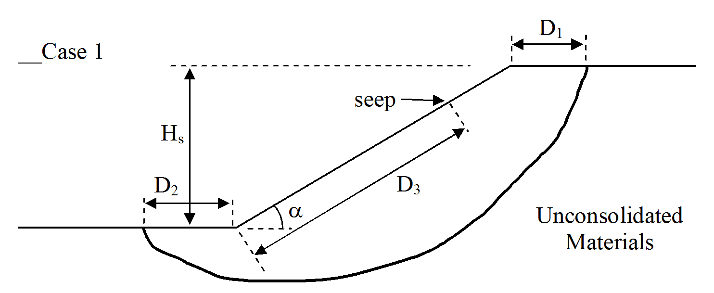 | - Average slope angle, α,_________  - Height of slope, H_{s} (ft)__________  - Length of slope repair, L, parallel to highway (ft)___________________  - Distance from crest of slope to failure surface, D₁(ft)____________  - Distance from toe of slope to failure surface, D₂ (ft)_________________  - Distance along slope (measured from toe) to groundwater seeps, D₃, and approximate quantities of groundwater (ft)________________
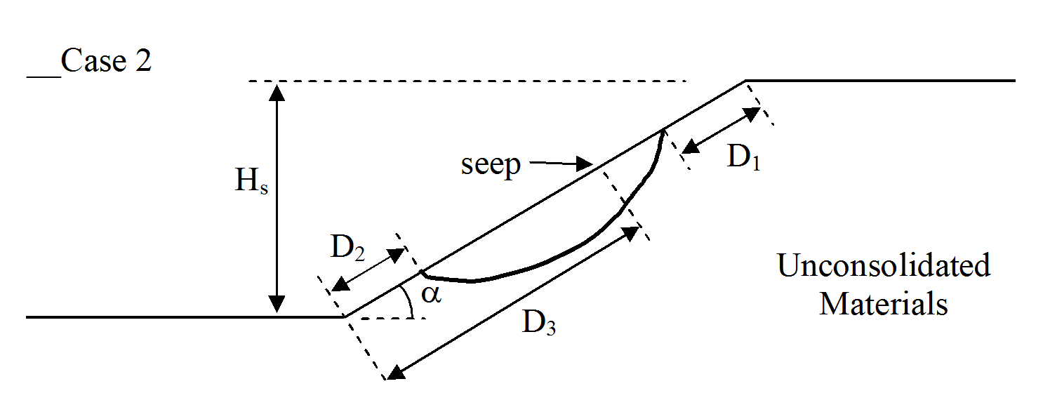 | - α,______________________  - H_{s} (ft)___________________  - L(ft)____________________  - D₁(ft)___________________  - D₂(ft)____________________  - D₃(ft)____________________
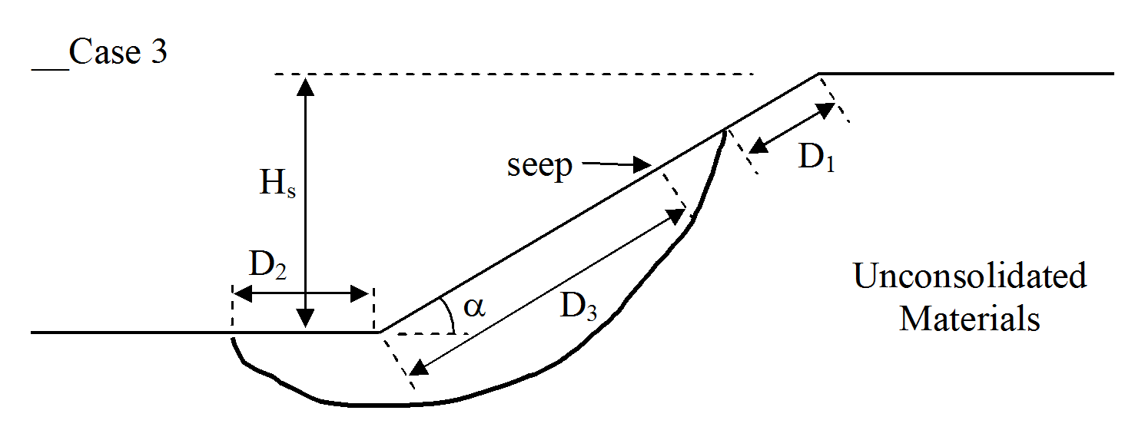 | - α,______________________  - H_{s} (ft)___________________  - L(ft)____________________  - D₁(ft)___________________  - D₂(ft)___________________  - D₃(ft)___________________
 | - α,______________________  - H_{s} (ft)___________________  - L(ft)____________________  - D₁(ft)___________________  - D₂(ft)___________________  - D₃(ft)___________________

Cost Estimate

Repair cost

Benefit cost ratio

Estimated time required for remediation (days) | _________days
C.7/14
Part C (continued)
Landslide Inventory Number
-
Suggested Remediation Measure

__Benching & regarding

__ Counter berm & regrading
__Flattening Slope
__Soil Drainage
__Bedrock Drainage
__Retaining Walls
__Light Weight Fills
__Dynamic Compaction
__Bio-engineering
__Geofabrics
__Sheet Piling
__H Piling
__Drilled Piling
__Soil Nailing
__Tieback Walls
__Remove & Replace
__Shear Key
__Chemical Treatment
__Relocation
__Bridge
__Change Line or Grade
__Other________________

C.8/14
Part C (continued)
Landslide Inventory Number
-

Sources of Supplemental Information

__Aerial photos __Field visit
__Satellite imaginary __Local people
__County-ODOT __Dist-ODOT
__State-ODOT __City and county engineer
__Soil/Rock/Water samples __GPS features
__Folder/ File location __Academia with engineering or geology program
__USGS publications and files __USGS Quadrangles
__USGS open file map series #78-1057 “Landslide related features”
__Division of geological survey (ODNR)
__Division of mineral resource management (ODNR)
__Division of soil and water (ODNR)
__Others______________________________________________

C.8/14
C.9/14
Part C (continued)
Landslide Inventory Number
-

Landslide hazard rating matrix
CATEGORY |  | RATING CRITERIA and SCORE |  |  |  | Total  Item  Scores
 |  | Points 3 | Points 9 | Points 27 | Points 81 | Total  Item  Scores
Movement location/  impact  (select higher score) | Current and potential impact of landslide on roadway | On slope with a low potential to affect shoulder | On slope with a low potential to affect roadway | On shoulder, or on slope with a moderate potential to affect roadway | On roadway, or On slope with a high potential to affect roadway or structure
Movement location/  impact  (select higher score) | Current and potential impact of landslide on area beyond right of way | On slope with a low potential to impact area beyond right of way | On slope with moderate potential to impact area beyond right of way | On slope with high potential to impact area beyond right of way | On slope with high potential to impact structure beyond right of way
Hazard to traveling public  (Select higher score) | Rate of displacement in roadway if known | <1-inch/year | 1 to 3-inches/year  No single event  ≥1-inch | 3 to 6-inches/year  No single event  ≥3-inches | >6-inches/year  Single event  ≥3-inches
Hazard to traveling public  (Select higher score) | Evidence of displacement in roadway | Visible crack or dip no vertical drop | ≤1-inch of displacement | 1 to 3-inches of displacement | ≥ 3-inches of displacement
Maintenance  (Select higher score) | Maintenance  frequency | None to rare | Annually  (one time/year) | Seasonal  (1 to 3 times/ year) | Continuous throughout year  (> 3 times/year)
Maintenance  (Select higher score) | Maintenance  response | No response | Requires observation  with periodic maintenance | Requires routine  maintenance response to preserve roadway | Requires immediate response for safe travel or to protect adjacent structure
%Decision Sight Distance (%DSD) |  | ≥ 90 | 89 -50 | 49-35 | < 34
ADT |  | <2000 | 2001-5000 | 5001-15000 | >15001
Accident history  (Related to landslide) |  | No accident | Vehicle or property damage | Injury | Fatality
 |  |  |  |  | Total Score
C.10/14
Part C (continued)
Landslide Inventory Number
-
Hazard calculation sheet
Hazard category | Explanation | Item Scores
- Movement Location/ Impact
- Hazard to Traveling Public
- Maintenance
- %DSD

- ADT
- Accident history
(Related to landslide)
Total score
C.11/14
C.11/14
Part C (continued)
Landslide Inventory Number
-
Detailed mapping with physical measurement
Include all locations of crown, root, edges, spring, surface water, cracks, toe bulge, sloughing, head scarps, guardrail distortion, linear deflections, stream deflections, toe erosion, hydrophytic vegetation, J-trunk trees, slanted poles /trees and etc. The sketch should indicate direction (north arrow), draw to scale, and include reference points for cross section. 
Plan:
C.12/14
Part C (continued)
Landslide Inventory Number
-


C.13/14
Cross-section:
Part C (continued)
Landslide Inventory Number
-
Additional Pictures
Provide additional pictures of physical evidence as stated in page C. 12 (provide a folder for storing digital pictures)

C.14/14

