B-001-0-19
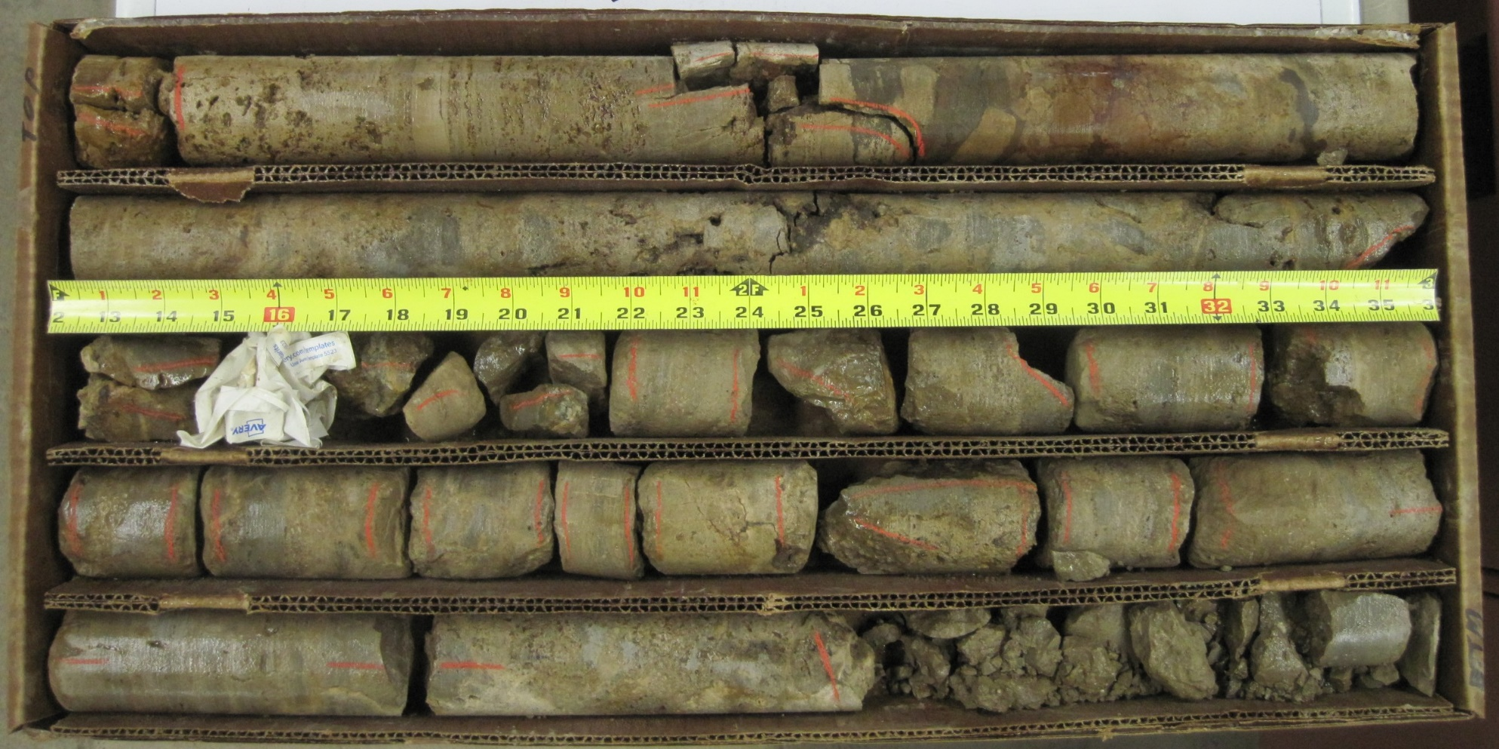
ER: NQ2-1
35.0’ BR: NQ2-2

ER: NQ2-2
40.0’
BR: NQ2-1
30.0’
Run #: | Depth |  | Recovery |  | RQD
NQ2-1 | 30.0’ | 35.0’ | 51/60 | 85% | 40/60 | 67%
NQ2-2 | 35.0’ | 40.0’ | 56/60 | 93% | 17/60 | 28%
ROS-138-10.98 PID 105103

