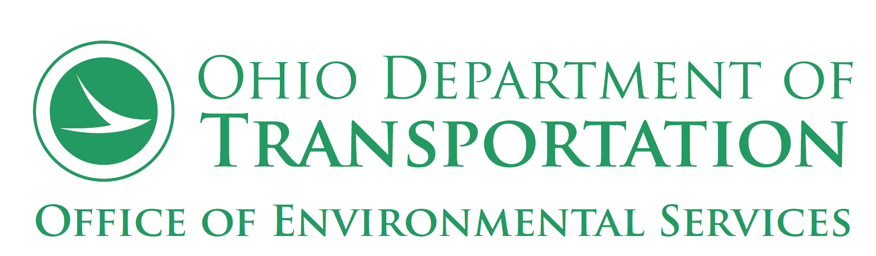

Underserved Populations Documentation Form for C2 Projects (Rev. July 2019)

1. Are there any relocations?
a. Are there any residential relocations?
i. Is housing of Last Resort anticipated?
b. Are there business relocations?
i. Will any businesses primarily serving an Underserved Population be relocated
as part of the proposed project?
ii. Will there be any job loss for an Underserved Population as a result of the
business relocation?

2. Will there be changes to access?
a. Will access to shopping, bus stops, schools, jobs, recreational resources, community
centers, etc. be diminished or completely restricted on a permanent basis, for an
Underserved Population?
b. Will man-made dividers such an overpass, bridge, 4-lane or greater roadway or railroad negatively impact the extent to which a community feels connected or cohesive for an Underserved Population?

c. Will access to or use of the transportation improvement be denied to any Underserved Populations (for reasons such as cost to use, ability to access, etc.)?

3. Will the proposed project result in unanticipated additional impacts to any Underserved Populations?

4. Were any concerns related to impacts on Environmental Justice Populations or any other unique factors that could result in a disproportionately high and adverse effect raised during Public Involvement?

5. Were any concerns related to impacts on Title VI Populations or any other unique factors that could result in a disparate impact raised during Public Involvement?

6. Were any concerns or any other unique factors that could result in an impact to any of the other Underserved Populations (Limited English Proficiency, Older Adults, or Individuals with Disabilities) raised during Public Involvement?

