Ohio Department of Transportation
Office of Statewide Planning & Research
Research Section
1980 West Broad Street, Mail Stop 3280
Columbus, OH 43223
614-644-8135
Research@dot.state.oh.us
www.dot.state.oh.us/Research

Probabilistic Use of LiDAR Data to Detect and Characterize Landslides

FHWA Report Number: | FHWA/OH-
Report Publication Date: | May 2015
ODOT State Job Number: | 134609
Project Duration: | 45 months
Start Date: | 08/04/2011
Completion Date: | 05/04/2015
Total Project Funding: | $594,566.00
Research Agency: | The Ohio State University, CEGE
Researchers: | Drs. Dorota Brzezinska and Charles Toth
ODOT Technical Liaisons: | Kirk Beach and Stephen Taliaferro (current)

For copies of this final report go to http://www.dot.state.oh.us/research.

Project Background
Landslide hazard and its consequences in the transportation network are well-understood, yet current methods of identifying and assessing landslide conditions are inefficient, as they are mostly based on labor-intensive field surveys. In addition, many sites are not easily accessible to land crews. Landslides are an ever-present risk to Ohio’s state highway system. The ODOT Office of Geotechnical Engineering (OGE) is currently facing landslide hazards in all of its districts, and some of these districts (e.g., Districts 8, 9, and 10) have several hundred of problem sites. Landslides that are impacting the roadway (e.g., guardrail, shoulders, cracks, sags, displacements) are generally known to county managers and District engineers by way of maintenance crews. On the other hand, landslides that are not yet impacting a highway are more difficult to detect and may pose a future hazard. In order to have better forewarning of these threats and to save on remediation cost in many cases (i.e., generally remediation costs increase as a landslide progresses), the OGE is searching for a means to identify and assess landslides as early as possible. Using field crews to scour every adjacent cut and fill slope for Ohio’s state highway system is completely impractical. Therefore, OGE is interested in developing a method to automatically search for and assess the magnitude of landslides using remote sensing data.
Light Detection And Ranging (LiDAR) technology has seen phenomenal developments in the past ten years, resulting in higher spatial resolution and more accurate surface representations. Therefore, this technology is a prime consideration for landslide detection and monitoring, as it is relatively easily available and efficient. Given Ohio’s extensive road infrastructure and its fast rate of deterioration, the research to assess the feasibility of LiDAR for landslide identification is of high urgency. This study has been prepared to address this need in the form of a pilot project, with cooperation between ODOT, The Ohio State University (OSU), and Kent State University (KSU).

Study Objectives

The research was performed as a feasibility study, where the potential of airborne LiDAR data for landslide detection was investigated. The primary objective of this pilot study was to develop, implement and validate computer models for automatic detection and assessment of landslides using time-series of airborne LiDAR data. Models have been developed using LiDAR data obtained from SR 666 in Muskingum County (District 5) and independently tested on LiDAR data covering southern Ohio. Since the landslide identification is based on change detection, a test area was selected by ODOT where past LiDAR data of good quality were available. While the key aspect of LiDAR data is that it is a remote sensing technology, yet for performance validation and reference, the necessary ground surveys were conducted in consultation with the OGE staff.

Description of Work

The performed work included a balanced amount of algorithmic research, initial implementation, field surveys (to validate reference), data testing, data analysis (data acquisition by ODOT), software developments and technical report preparation. Most of the algorithmic developments were implemented in the Matlab environment. The major milestones are listed below:
- The research team lead by The Ohio State University (OSU) and included Kent State University (KSU) and University of Cincinnati (UC) experts evaluated the report on Geohazard Inventory and Evaluation, MUS-666-0.00, PID 79462, ODOT OGE, November 2006. The objective was to identify areas that are suitable for obtaining landslide references. A short list of candidate landslides was prepared and an agreement was reached on what landslides should be initially considered in the investigation as reference.
- A special project meeting was arranged to review the landslide assessment and practice at the Zanesville office of OGE and to visit the designated test site, a 15 mile section of Muskingum State Route 666. This event allowed to update the landslide reference list, as based on the inspection, several landslide changes were identified, such as certain parts had been resurfaced or other remediation occurred.
- Based on the short list, field surveys were carried to obtain accurate topographic representation of the reference landslides. The OSU team used GPS and total station surveying technology to obtain the outline and some cross-section profiles of selected landslides. The geotechnical assistance to identify and delineate the landslides was provided by the KSU team. In total, nine landslides from four different sections along SR 666 were surveyed and, subsequently, used in the algorithmic developments and testing. In parallel, literature review was performed at OSU, and KSU was investigating the creation of a GIS database.
- The objective of the algorithmic research and developments was to create an experimental technique that is able to identify landslide prone regions, based on surface analysis, and thus, early warning signs of potential landslide activity can be created. Note that the terrain surface is obtained by high precision airborne LiDAR. In this study, different methodologies were investigated to understand and model the behavior of landslides, including geomorphic features, geomorphologic shape (profile and shape based) and change detection. The long-term goal is to design a highly automated landslide detection algorithm that will identify potential landslide araes with high probability. The availability of landslide reference data was essential to support this work, as it provided the basis to correlate surface features to landslides.
- In the implementation phase, two methods were developed. The first one aims to extract landslide suspect areas based on surface shape (morphology). This tool can be used if an area is surveyed for the first time, as it can provide an initial list of areas prone to develop to landslides. The second method is based on temporal data analysis; besides the spatial one. First change detection is performed, and then changes are evaluated based on a statistical model. Finally, changes considered significant are subject to the first approach to obtain the landslide map of the area. Note that there may be changes in the surveyed area due to construction, etc.
- To support both the development work as well as to provide OGE with a landslide data base, a GIS data base was created to include all the data layers over the SR 666 road. Besides, the standard GIS layers, the database incorporates all the intermediate and final results of all the algorithms tested. This tool was extremely essential for testing and algorithmic design refinement.
- Once the initial implementation was completed and the GIS database was created, an intensive testing was performed. The entire section of SR 666 was processed and compared to the report, PID 79462. In addition, geotechnical experts from three groups provided further evaluation and assessment on the performance of the method. Once testing advanced to a routine work, then a copy of the implementation was provided to OGE for in-house testing there.
- To further assess and potentially improve the developed method, additional data was needed that was not used in the developments. At that point, OGE provided six LiDAR datasets that were extremely important to test the developed approach with respect to data dependency. These tests provided some feedback for performance tuning too.
- Final task of the research was to address the quality of the geospatial data that form the input to the developed landslide hazard detection tool and has a major impact on performance. LiDAR data are generally characterized by two major parameters: point density and vertical accuracy. Both parameters are essential to obtain good surface representation, so the landslide specific features can be successfully extracted. The spatial resolution and vertical accuracy jointly determine the performance level that is needed for extracting a certain surface feature size. Based on the SR 666 data, a simulation data set, DEMs ranging from dm to m level spacing, was created and all the tests were performed at these different resolution surfaces to assess the detection performance as a function of point spacing.

Research Findings & Conclusions

In this research effort, two techniques, one using single and the other based on multi-temporal surface models, obtained by airborne LiDAR, were proposed, implemented and tested for landslide susceptibility and hazard mapping. To assess the archived performance, two aspects should be mentioned. First, the performance of both methods depends on the spatial resolution of LiDAR data, and the developed approaches reflect on the data characteristics that were available to support this research work. Second, the human subjectivity in judging landslides brings in additional non-negligible uncertainties to the reference landslide inventories that form the basis for any comparative evaluation. The main performance achievements are:
- Using the first approach that extracts landslide suspect areas based on a surface model, an 84% performance level was archived; i.e., 84% of the landslides from the reference inventory map of SR 666 were correctly identified. For the independent data sets, it is impossible to put a number on performance as no reference data was available for the six areas. Based on OGE experts’ assessment, however, all the detected landslide suspect areas were deemed correct, and only one known landslide was missed by the method.
- The performance validation of the second, temporal data analysis based method is limited, as only a second LiDAR survey of SR 666 was available; unfortunately, there were no independent data sets. For SR 666, the proposed technique was able to identify 66% of the mapped landslides that are experiencing temporal changes susceptible to slides when compared to the reference inventory map.
- The results of the simulation study are also quite valuable, as the outcome clearly points to the importance of the spatial resolution, as the most important factor to achieve a good landslide suspect detection performance. Since the landslides in Ohio fall into the small slide category, the LiDAR data spatial resolution is the single most critical factor to achieve high performance. The higher the resolution, the better the detection rate.
- The promise that with the use of high precision airborne LiDAR the landslide activities can be detected has been confirmed. The implementation of an automated landslide detection algorithm can reduce the need for onsite data collection, and thus, field surveys time to identify landslides could be minimized, and, consequently, reducing the cost and time to identify and act upon warning signs of landslide developments.

Recommendations for Implementation of Research Findings

The introduction of a landslide suspect area detection system can significantly improve the overall landslide monitoring and remediation processes at OGE. Since ODOT is acquiring an increasing amount of LiDAR data over the transportation network for other purposes, such as road design, environmental, hazard, etc., studies, these data sets can be simply subjected to a landslide detection system, as the data are already available. Obviously, dedicated LiDAR surveys can be also arranged for areas of high interest in geotechnical sense. Regardless from how the data were acquired, the flagged areas by the system can be handled with priority at OGE, resulting is less time that the crews need to spend in the field. Some major specific recommendations are:
- To achieve a consistent and good performance, additional reference data are needed to test the developed methods, and, if needed, adjust them. In this study, both the training data as well as the independent test data were limited and insufficient is statistical sense. In addition, the more diverse the landslide data the better.
- To improve landslide identification in both performance and capabilities to identify most landslide types, a spatial resolution similar to the morphological features found in small failures is needed in the input LiDAR data in high accuracy. Based on our study, it is recommended that future airborne LiDAR acquisitions be acquired having a point spacing of 20–30 cm or even better.
- The introduction of UAS technology for landslide detection and monitoring is highly recommended. This inexpensive platform has an enormous potential in acquiring data at high spatial and good temporal resolution with excellent accuracy. LiDAR manufacturers are rolling out new small yet powerful sensors for UAS platforms. Compared to airborne platforms, UAS can follow more or less any road pattern and map an evenly split swath along the centerline. Some of these sensors feature 0.5M points per second data acquisition rate, which combined with slower platform motion, can provide high spatial resolution surface data. Since UAS operations are affordable, 2-4 surveys per year can be easily implemented over roads of high concern, ultimately resulting in temporal sampling that is comparable to most landslide growth rate.

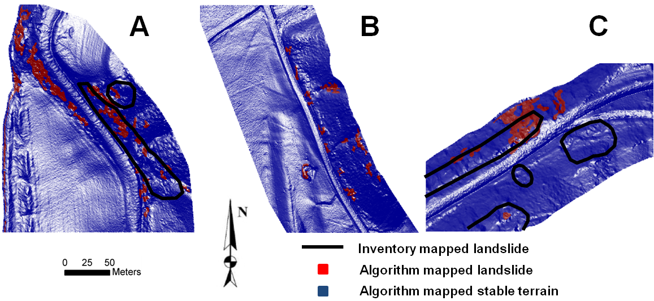
Sample results for single surface based landslide suspect area detection.

