**Contents**

Make sure the Email Calendar menu item is available 2

Open MS Outlook and locate the DOT CEN Auditorium calendar 3

Select and Fine Tune the E-mail Calendar output 4

Refining the generated E-mail Calendar to Share 5

Saving the Email as an HTML file 10

Uploading the calendar HTML file to share with the public 12

Confirm the update occurred 13

**OVERVIEW**

The ODOT Auditorium Scheduling and Request process is updating so that ONLY Authorized Personnel will be able to view and manage the Outlook-based reservation process. All requests for booking the Auditorium (from internal ODOT personnel and/or for other eligible state agency folk) will be handled through the public facing ODOT CO Auditorium webpage at

[ODOT Central Office Auditorium Information | Ohio Department of Transportation](https://www.transportation.ohio.gov/about-us/resources/co-auditorium-info)

Which links to the Formstack Scheduling Form at

[ODOT CO Conference Room Scheduling - Formstack](https://odot.formstack.com/forms/odot_co_conference_room_scheduling)

In order to stage, update, and publicly share a snapshot of the DOT CEN Auditorium Calendar so that requestors can see which days are booked or available, the following instructions are to be followed.

These steps below identify how authorized Auditorium Outlook scheduling users can easily produce and export a useful six-month calendar page that will be made available for as a reference link to be used when the requestors complete the Scheduling Form process. Exporting and updating can and should be done as often as necessary to keep the shared calendar accurate for review by the rest of ODOT and other eligible state agency employees. It is advised to perform this update and posting at least once a day, or as needed when new events are added.

# Make sure the Email Calendar menu item is available

Recent updates to Outlook may have removed the Email Calendar option from the Share Ribbon. To restore/readd this necessary tool, please do the following:

Right click ANYWHERE BLANK in the top Ribbon area and choose Customize the Ribbon.



Expand the “Choose commands from” pulldown to All Commands, then look alphabetically under e for Email Calendar. It will want you to make a new Tab to add it to (you can also rename it so you can find it more easily).

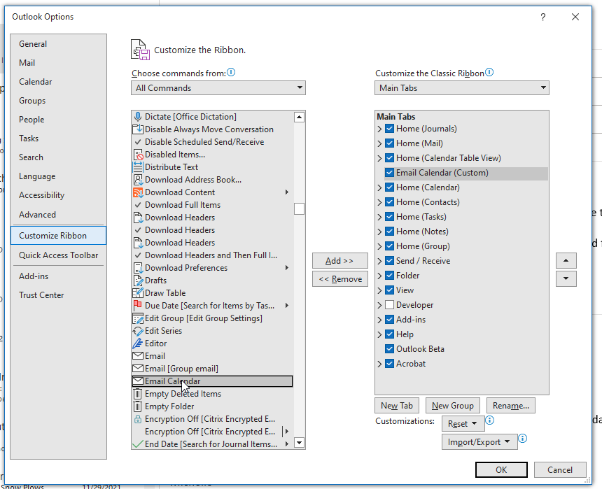

Once you’ve added the new tab and returned that command button to be available, then all the other steps should be the same.

# Open MS Outlook and locate the DOT CEN Auditorium calendar

Look under the left tab for the calendar Icon, the specific Room should be available but use the ribbon’s “Open Calendar” > From Room List and look for DOT CEN Auditorium if not. 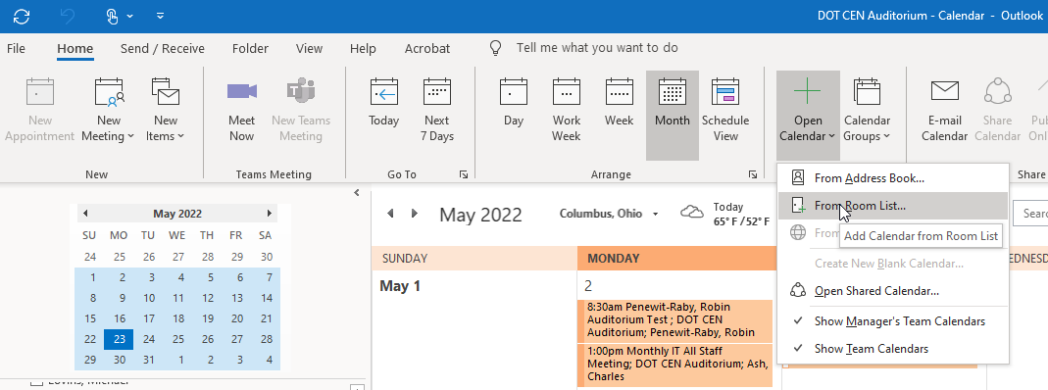  
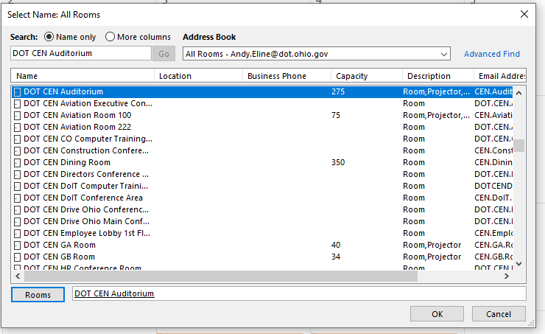

The DOT CEN Auditorium item should show under “Rooms” once loaded. Make sure NO other calendars are active and that only this room is showing in the calendar view (any “Arrangement” view – day work week, week, month OR schedule is OK – but make sure you turn any other personal or room calendars off so that ONLY this DOT CEN Auditorium calendar is used at this time). Then select **“OK”** to view the calendar.

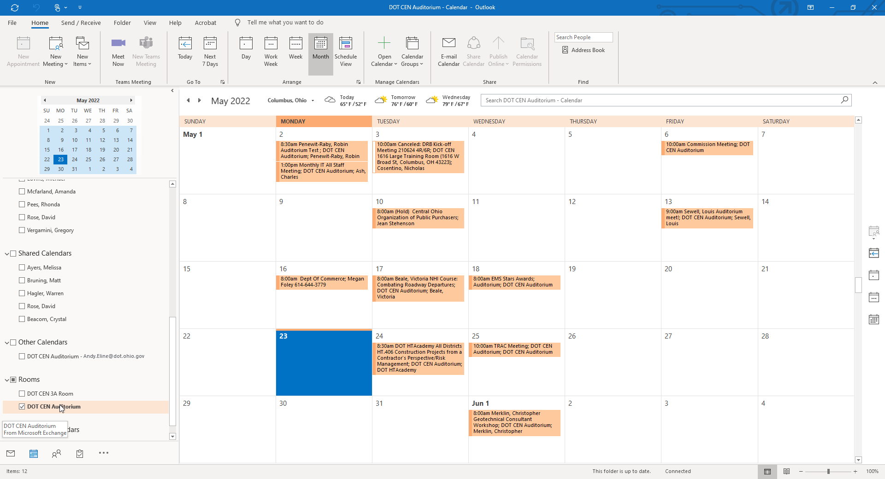

# Select and Fine Tune the E-mail Calendar output

Go to the Share ribbon area and select **“E-mail Calendar”** (may be the only available option from other greyed out results)

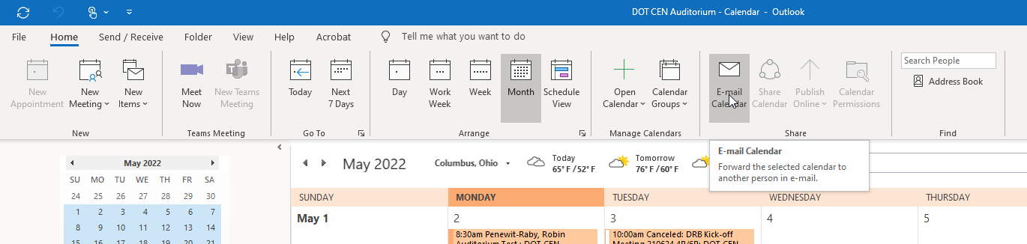

In the dialog box that pops up, click the Date Range drop down box and select “**Specify dates**” from now (Start = today) until 6 months from now (End = today + 6 months). For the Detail, pick Availability Only. Don’t worry about the show time… or setting the working hours, but DO select Advanced and for Email Layout > switch it to be **“List of Events”** (this is crucial to get the right look).

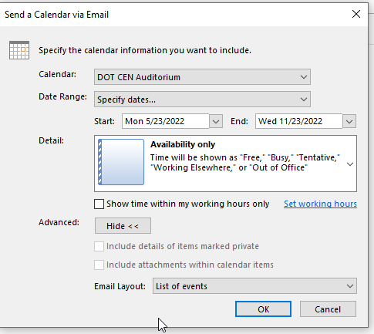

Once you click **“OK”**, a new draft email should generate with an attachment AND full body message with a custom calendar and list of events. Next, we will use that base email to create the version to share with the public.

# Refining the generated E-mail Calendar to Share

The new draft Email is good, but before we save it out, there are some things we can do to clean it up and make it more understandable to the public. Specifically, we need to remove the listing below so that only the calendar with the booked days marked (which we will change to RED) will be shared.

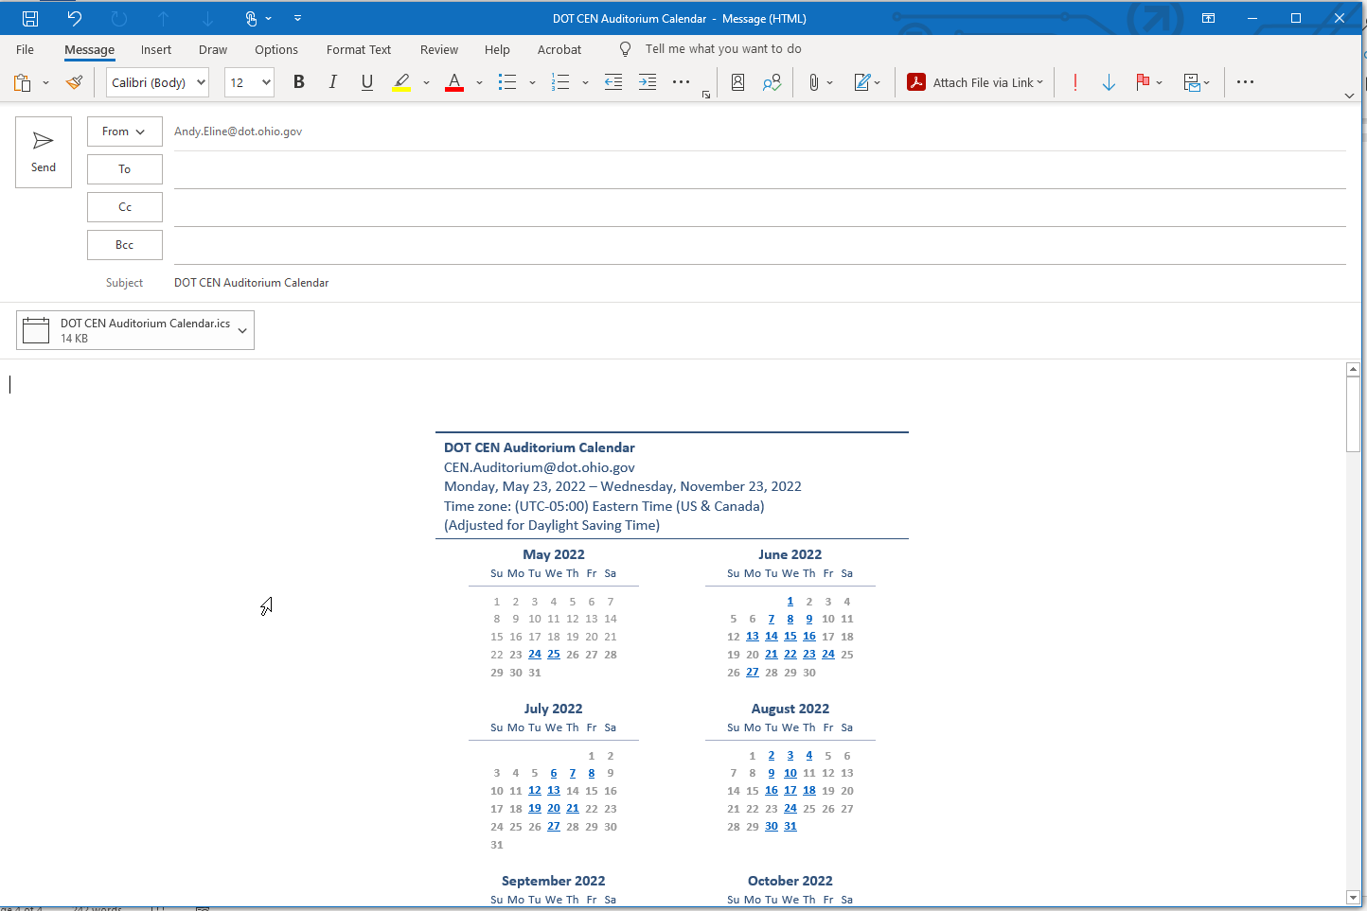

First, delete the attachment (it is not needed). Right click on the little Icon for it and chose “**Remove Attachment”**

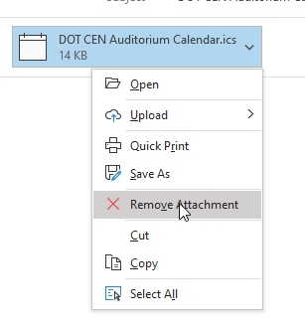

Then use the Ribbon and look for the Options > Themes > Colors menu, select **“Customize Colors”**

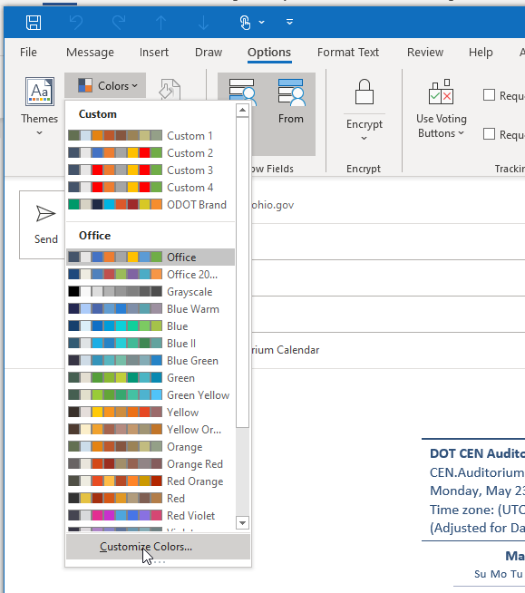

In the Create New Theme Colors dialog, pick the Hyperlink option and change the color from the blue to RED (should be a standard color, likely the second option) and click **“Save”**

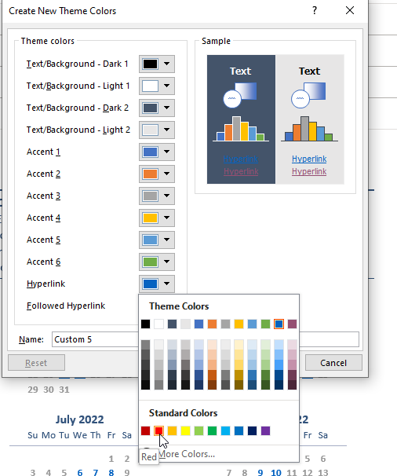

All the Booked Days should turn to UNDERLINED RED

In the Body of the draft email paste this at the top (ideally centered and colorized exactly as shared here)

BOOKED DAYS ARE MARKED IN RED AND UNDERLINED  
Available days are grey with no underline  
*Saturdays and Sundays ARE NOT available*

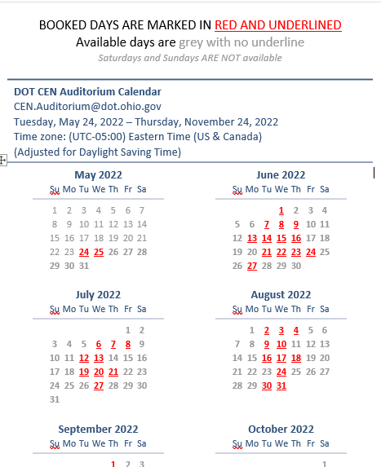

Then scroll down to the listing area below the calendar months, and click on the area to the upper left of the first upward yellow arrow (it’s tricky, but if you hit it just right, all the lines from that table will be selected – as indicated in a grey selection all way across and down, and then select **“Delete Table”** in the mini menu that appears to clear that bottom part out completely. Not sharing the booked times list, but only booked days is what’s intended and the calendar only part shows that well!

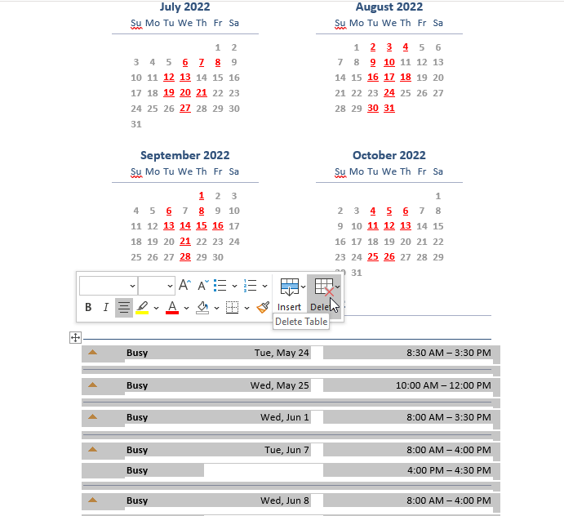

You can and should also clear out any default signature your draft email may have to clear that out. (highlight it and hit delete )

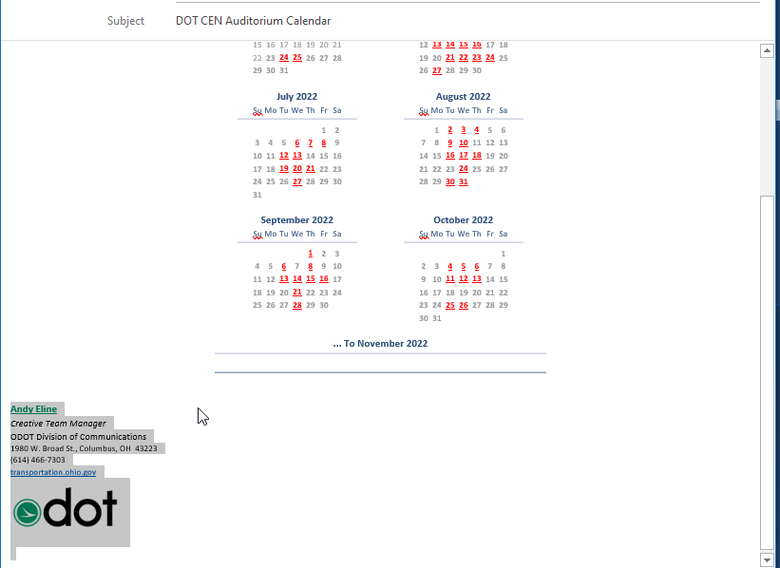

You should have all you need in one tidy email (but we’ll be saving it as an HTML file instead of actually sending an email, instructions follow).

# Saving the Email as an HTML file

Click the File menu atop the ribbon

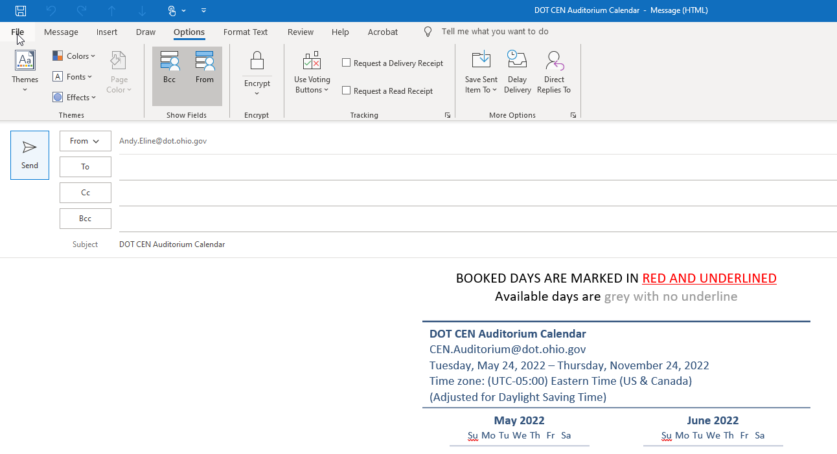

Look for and select the Save As option

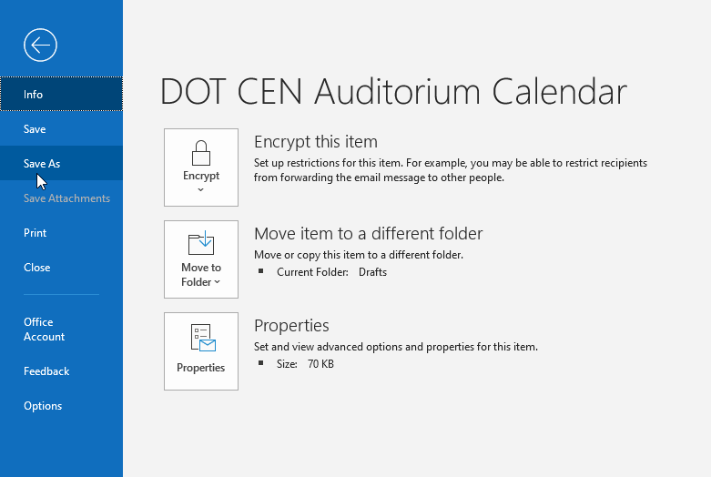

In the Save As dialog box, change the Save as type: to HTML.

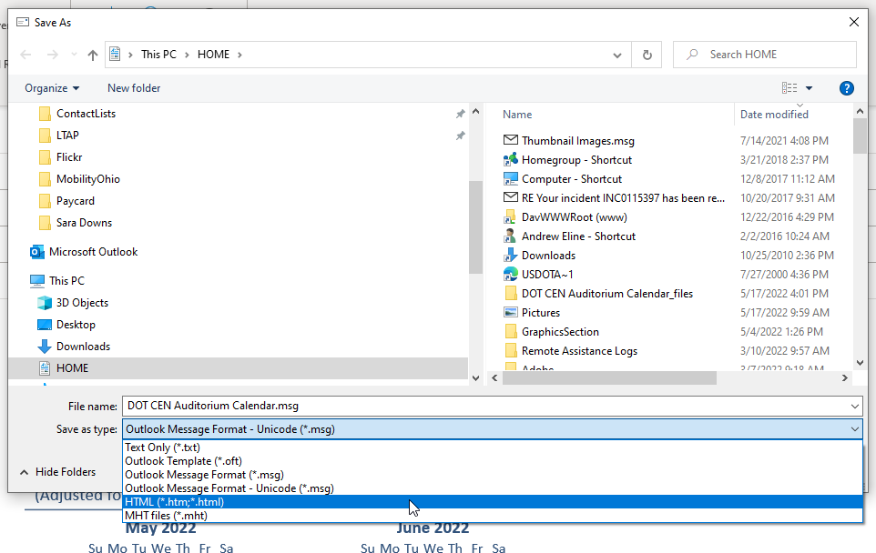

Pick a location you can find to save the file, BUT ALWAYS use the same name (try to use the default of “DOT CEN Auditorium Calendar.htm” – OVERWRITING THE PREVIOUS VERSION WITH THE SAME NAME IS A MUST, that is, for the form the public uses to access the new files, they must replace the old with the same name in the same spot!) Select **“Yes”** to replace the already existing file.

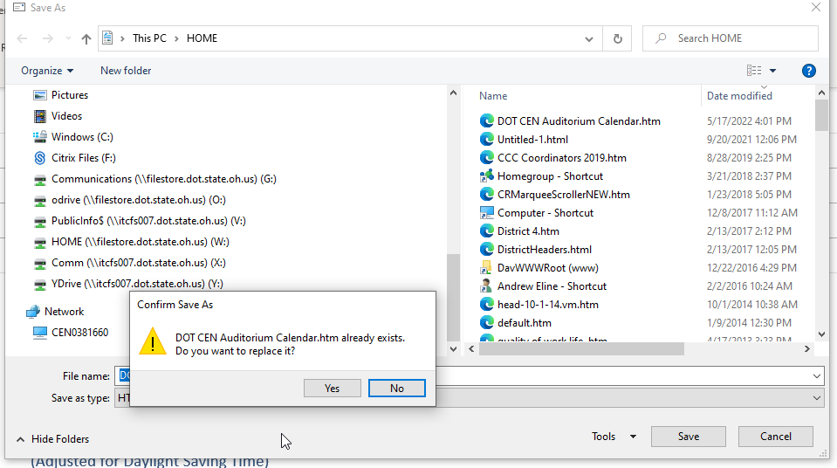

The local copy (which you can put anywhere you’d like, but can easily find) is now staged and ready to upload!

You can now close the draft email as it is no longer needed.

# Uploading the calendar HTML file to share with the public

Visit this SharePoint library: <https://www.dot.state.oh.us/auditorium/Forms/AllItems.aspx>

Click the semi-hidden “Sign In” option in the grey bar near the uppermost left corner (arrow will turn to hand). It should know who you are and log you in based on your ODOT AD windows account (but only authorized folks, currently Maria Johnson, Michelle Saunders, and Jessica Koren are in the contributor’s group).

Once you’re logged in, the page should show your name in the upper right, and you’ll now have menu options to manage files.

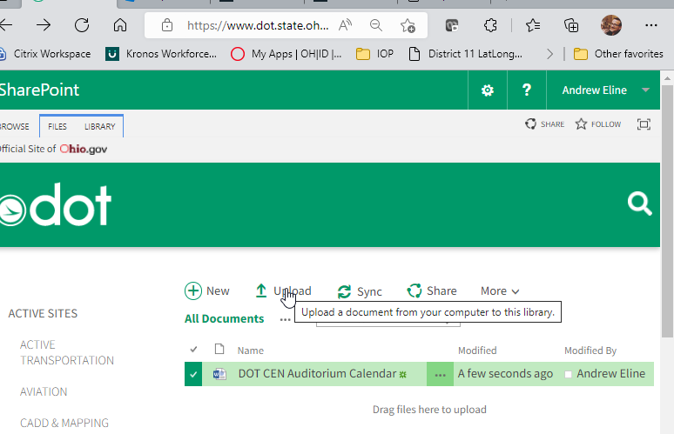

If everything goes to plan, your file name will be the same as the existing one. If you choose **“Upload”** and then **“Choose File”** to browse to, select and click **“Open”** for your latest version of that file then make sure the next dialog box has a check for **“Overwrite existing files”**, everything should be good to go!

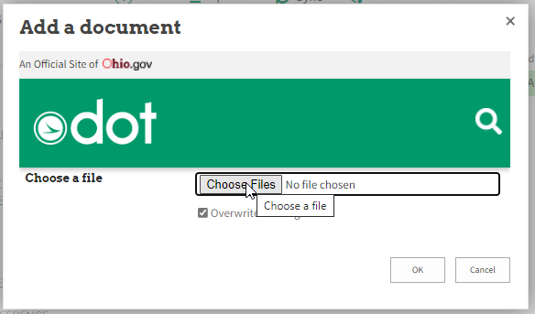 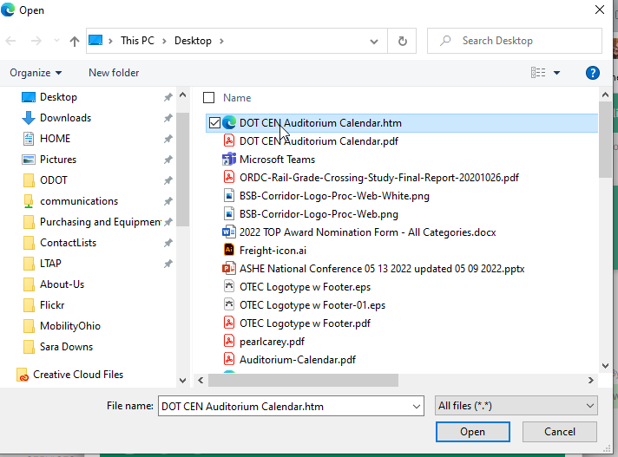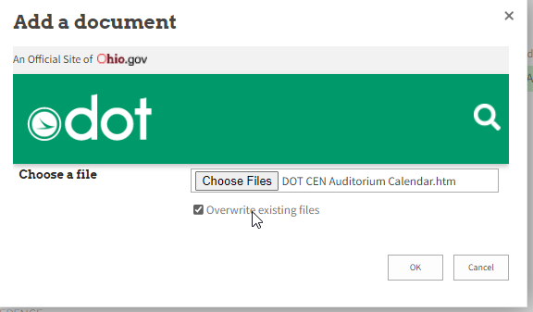

If everything worked, there should still only be ONE file in that library, and the Modified info should say “A few seconds ago” and your name should be in the Modified By column.

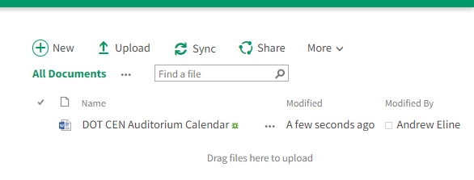

# Confirm the update occurred

You can CONFIRM that the request form’s link is connected to the updated file by clicking this link (which is the same address used in the form itself). <https://www.dot.state.oh.us/auditorium/DOT%20CEN%20Auditorium%20Calendar.htm>

Load the calendar HTML page and see if the start date line is accurate for today’s date through the next 6 months

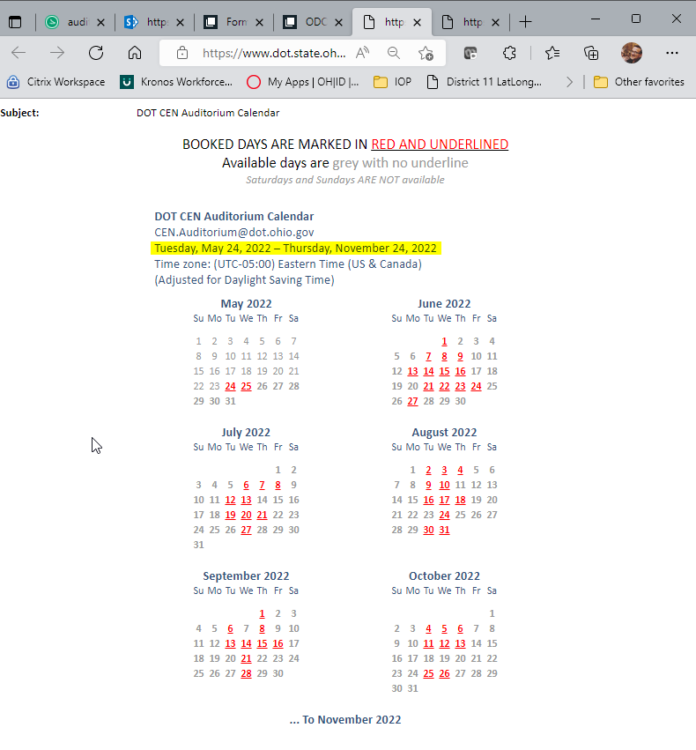

THANKS!

Contact [Andy.Eline@dot.ohio.gov](mailto:Andy.Eline@dot.ohio.gov) with any questions, concerns or issues with this process.