Rest Area and Miscellaneous Signs

D5-H7aP D5-H7bP D5-H7c
108” x 48” 108” x 24” 144” x 72”

D5-H9aP D5-H7d
120” x 48” 156 x 72”

Rest Area and Miscellaneous Signs (continued)

D5-H17 D5-H19
(Sec. 208-4) (Sec. 208-5)

D5-H18 D5-H21 D5-H22 D5-H23
(Sec. 208-5) (Sec. 208-5) (Sec. 208-5) (Sec. 208-5)

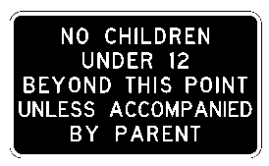
D5-H24 D5-H25 D5-H26 D5-H27
(Sec. 208-5) (Sec. 208-5) (Sec. 208-5) (Sec. 208-5)

D5-H28 D5-H29 D5-H30
(Sec. 208-5) (Sec. 208-5) (Sec. 208-5)

Rest Area and Miscellaneous Signs (continued)

