Lane-Use Control Signs Index
R3-5a R3-5L R3-5R R3-6L R3-6R R3-H6a R3-H6b R3-H6e
30x36 30x36 30x36 30x36 30x36 30x36 42x36 30x36
36x42 36x42 36x42 36x42 36x42

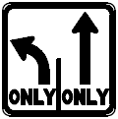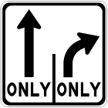
R3-H8 R3-H8ba R3-H8bb R3-H8bc R3-H8bd R3-H8be R3-H8bf R3-H8bg
30x30 30x30 30x30 30x30 30x30 30x30 30x30 30x30

R3-H8bh R3-H8bj R3-H8bk R3-H8bm R3-H8bn R3-H8bp R3-H8bq
36x30 36x30 36x30 36x30 36x30 30x30 36x30

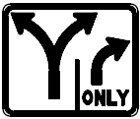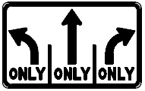
R3-H8bs R3-H8bt R3-H8bu R3-H8a R3-H8b R3-H8ca
36x30 42x30 42x30 48x30 48x30 48x30

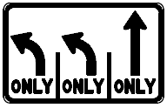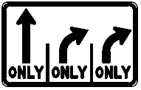
R3-H8cb R3-H8cc R3-H8cd R3-H8ce R3-H8cf
48x30 48x30 48x30 48x30 48x30

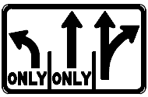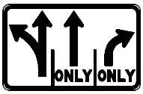
R3-H8cg R3-H8ch R3-H8cj R3-H8ck R3-H8cm
48x30 48x30 48x30 48x30 48x30

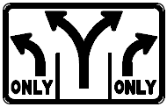
R3-H8cn R3-H8cp R3-H8cq R3-H8cs R3-H8ct
48x30 48x30 48x30 48x30 48x30

R3-H8cu R3-H8cv R3-H8cw R3-H8cx R3-H8cy
48x30 48x30 48x30 48x30 48x30
Lane-Use Control Signs Index (continued)

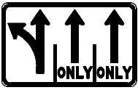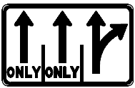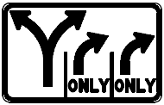
R3-H8cz R3-H8caa R3-H8cbb R3-H8ccc R3-H8cdd
48x30 48x30 48x30 48x30 48x30

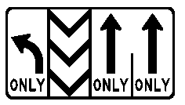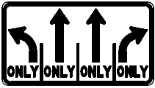
R3-H8cee R3-H8cff R3-H8cgg R3-H8chh R3-H8da
54x30 54x30 54x30 54x30 54x30

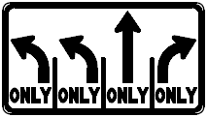
R3-H8db R3-H8dc R3-H8dd R3-H8de R3-H8df
54x30 54x30 54x30 54x30 60x30

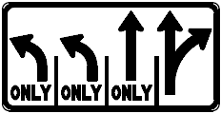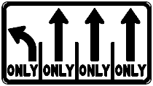
R3-H8dg R3-H8dh R3-H8dj R3-H8dk R3-H8dm
60x30 54x30 54x30 54x30 54x30

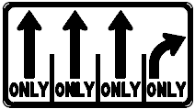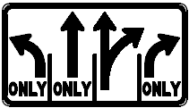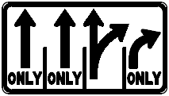
R3-H8dn R3-H8dp R3-H8dq R3-H8dr R3-H8ds
54x30 54x30 54x30 54x30 66x30

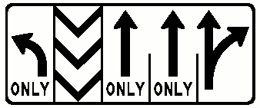
R3-H8dt R3-H8du
72x30 60x30

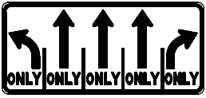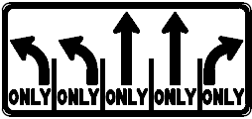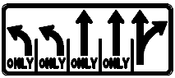
R3-H8ea R3-H8eb R3-H8ec
66x30 72x30 72x30

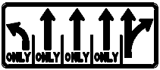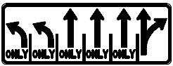
R3-H8ed R3-H8fa R3-H8fb R3-H8fc
72x30 78x30 78x30 84x30

