Solid Wood Posts

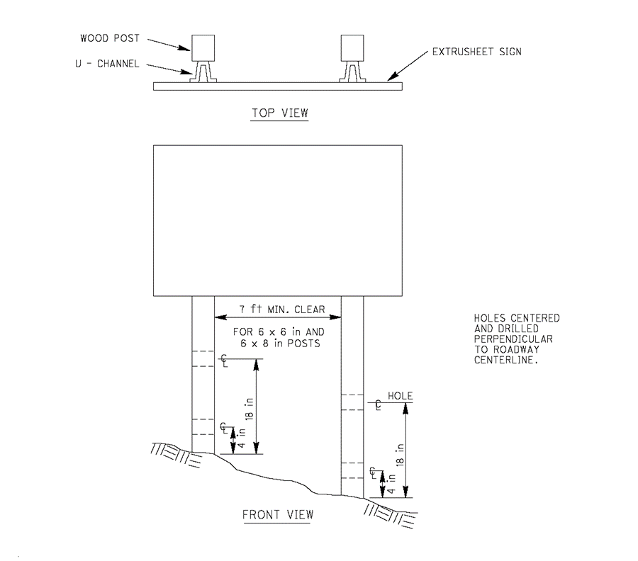

Recommended wind pressure to use in size calculations:

Wind pressure on sign = 15 lb/ft²
Wind Pressure on exposed post = 18 lb/ft²

Nominal Post Size  (inches) | Hole Diameter  (inches) | No. of Posts Permitted in 7’ Path in Exposed Locations | Minimum Recommended Embedment Depth  (feet) | Maximum Recommended Allowable Moment per Post  (ft-lb)
4 x 4 | None | 2 | 3.5 | 1050
4 x 6 | 1 ½ | 2 | 4 | 2540
6 x 6 | 2 | 1 | 4.5 | 3880
6 x 8 | 3 | 1 | 5 | 6580

