Design Charts for Laminated Veneer Wooden Box Beam Sign Supports

Two-Beam Installations (for signs 19’-0” or less in length)

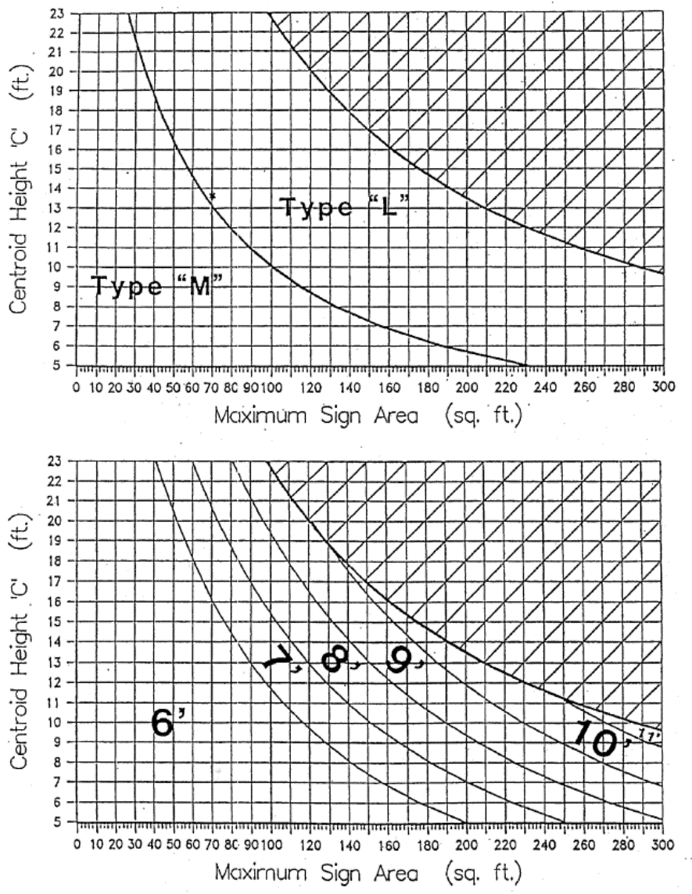

Top Chart = Beam Selection Bottom Chart = Embedment Depth

Design Charts for Laminated Veneer Wooden Box Beam Sign Supports (continued)

Three-Beam Installations (for signs over 19’-0” in length)

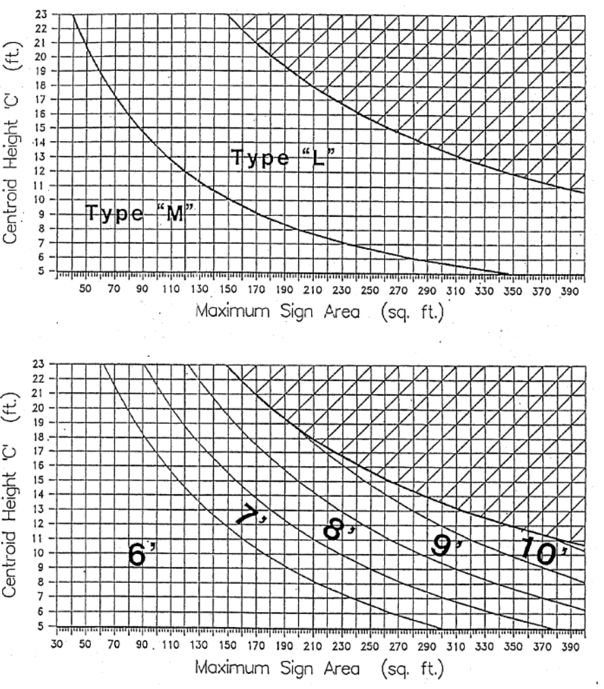

Top Chart = Beam Selection Bottom Chart = Embedment Depth

