Temporary Traffic Control Signs

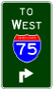 | 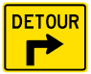 |  |  | 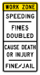
M2-H3  605-7.3 | M4-9 advance right turn  605-7.2 |  |  | R11-H5a  605-4.2
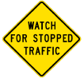 |  |  | 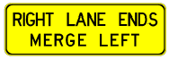
W3-H7  642-33 |  | W8-H15a  605-17 | W9-H4R  641-17
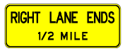 |  |  |  |  | 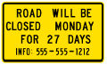
W9-H5  641-17 |  | W9-H6  641-17 |  |  | W20-H13  605-6.2
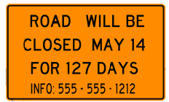 |  | 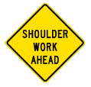
W20-H13  605-6.2 |  | W21-H5  606-6 |  |  | W21-H6  605-5.9
 |  | 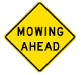
W21-H8
606-6

