Voltage Drop Study – Sample Voltage Drop Calculation

Co. FRA Rte. 99 Sec. 1.23 Sheet 1 of 1 Sheets
Power Service “A” Circuit B No. of Wires for Calculation Purposes: 2
Supply Voltage: 240/480 3-wire GND NEU
Wire Resistance Used: No. 4 AWG. 0.2582
No. AWG.

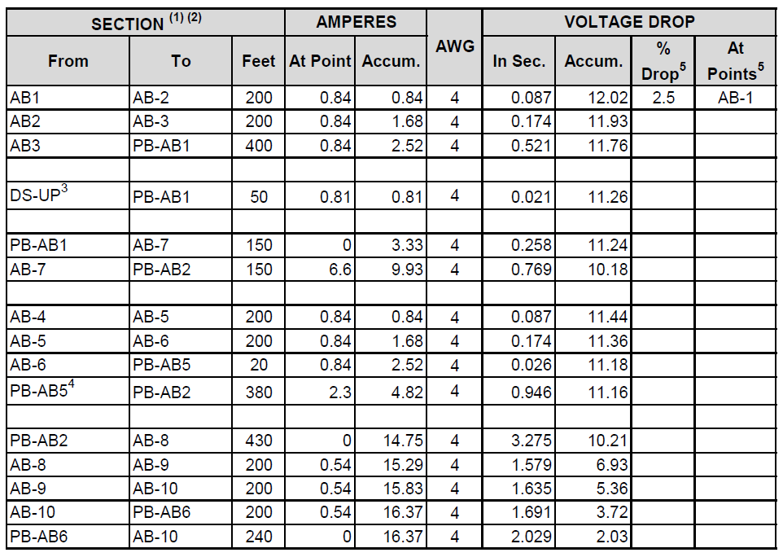

  - To avoid repetition, the power service designation “A” is omitted in the point designation.
  - Lighting unit lead and voltage drop is computed only to base of support to simplify calculation.
  - Underpass lighting load and voltage drop is computed only to disconnect to simplify calculation.
  - Sign lighting load and voltage drop are computed only to the point of connection to lighting circuit to simplify calculation.
  - These columns are normally only computed for the point of maximum voltage drop.

