Types of Overhead Sign Supports

Support Type | Allowable Sign Area, Sq. Ft. | Span or Arm Length, Ft. | Configuration | Notes
TC-17.11  Span Wire | 10 to 132 | 20 to 90 | 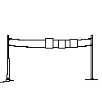 | -----------
TC-16.20  Single Arm | ------------ | Arm  23 to 45 | 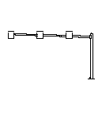 | -----------
TC-12.31  Cantilever | Up to 300 (Depending on Arm Length) | Arm  26 to 30 | 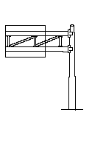 | Alternate Version - Made of Untapered Tubes.
TC-9.11  Semi-Overhead | Up to 150 | ------------- | 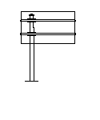 | Sign may be eccentric to pole.
TC-9.31  Center Mount | Up to 250 | __________ | 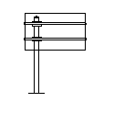 | Sign may be  eccentric to pole.

Support Type | Allowable Sign Area, Sq. Ft. | Span or Arm Length, Ft. | Configuration | Notes
TC-15.116  Steel Truss  (Steel End  Frames) | Up to 1150 | 40 to 150 | 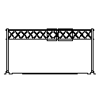 | 5' square box
Combination Sign  Support | According to  Sign Support | According to  Sign  Support | 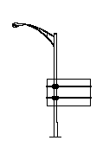 | May be used to add  a highway lighting  function to 16.21,  12.31, 9.11 and  9.31
TC-18.24  Structure  Mounted | ----------- | ----------- | 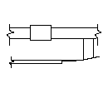 | Flush Mounting.  Aluminum Brackets
TC-18.26  Skewed Structure | ----------- | ----------- | 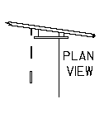 | Aluminum Structure

