Weight of Overhead Supports – Truss

Sign Support Type |  | Span, Ft. | Wt./Ft. | Total Wt. of Truss, lbs. | Configuration
Truss – end frames weigh from 1400 to 1800 pounds each.
7.2 | Des. 1 | 70 | 15.4 | 1150 | 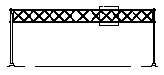
 | Des. 2 | 85 | 16.2 | 1375
 | Des. 3 | 105 | 21.4 | 2250
7.3 | Des. 1 | 55 | 16.8 | 925 | 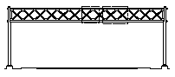
 | Des. 2 | 80 | 21.3 | 1700
 | Des. 3 | 90 | 21.1 | 1900
 | Des. 4 | 105 | 21.4 | 2250
7.4 | Des. 1 | 75 | 21.3 | 1600
 | Des. 2 | 85 | 21.2 | 1800
 | Des. 3 | 90 | 32.5 | 2925
 | Des. 4 | 110 | 32.7 | 3600
7.5 | Des. 1 | 70 | 21.4 | 1500 | 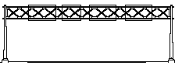
 | Des. 2 | 80 | 21.3 | 1700
 | Des. 3 | 86 | 32.6 | 2800
 | Des. 4 | 110 | 32.7 | 3600
7.6 | Des. 1 | 65 | 21.5 | 1400 | 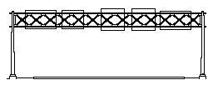
 | Des. 2 | 75 | 21.3 | 1600
 | Des. 3 | 80 | 31.1 | 2650
 | Des. 4 | 110 | 32.7 | 3600
TC-7.65 | Des. 6 | 55 | 21.8 | 1200
 | Des. 6 | 75 | 22.7 | 1700
 | Des. 8 | 75 | 29.0 | 2175
 | Des. 8 | 120 | 30.0 | 3600

Steel Truss – end frames weigh from 1600 to 2000 pounds each.
15.8 |  | 100 | 87.0 | 8700
 |  | 140 | 87.2 | 12200
TC-15.115 |  | 100 | 85 | 8500
 |  | 140 | 84.3 | 11800
Steel Truss – end frames weigh 3550 lbs. each
TC-15.116 |  | 75 | 77 | 5775
 |  | 120 | 136 | 16325
 |  | 150 | 171 | 25650

Span Truss – each pole weighs 775 pounds.
13.2 | Des. 1 | 50 |  | 1275 | 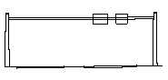
 | Des. 2 | 60 |  | 1500
 | Des. 3 | 70 |  | 1800
 | Des. 4 | 80 |  | 2150

Flat Truss – each pole weighs 1550 pounds.
14.5 | Des. 1 | 50 |  | 2250
 | Des. 2 | 60 |  | 2700
 | Des. 3 | 70 |  | 3200
 | Des. 4 | 80 |  | 2600
 | Des. 5 | 90 |  | 4050

