Weight of Overhead Supports - Semi-Overhead & Center Mount

Sign Support Type |  | Total Wt. of Support, lbs. | Configuration
Semi-Overhead
TC-9.10 | Des. 1 | 650 | 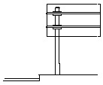
 | Des. 2 | 900
 | Des. 3 | 1300
Center Mount
9.12 | Des. 1 | 800 | 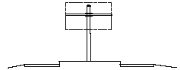
 | Des. 2 | 1100
 | Des. 3 | 1300
9.24 | Des. 1 | 1350 | 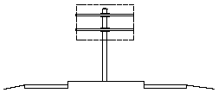
 | Des. 2 | 1550
 | Des. 3 | 1775
 | Des. 4 | 2300
TC-9.30 | Des. 1 | 975 | 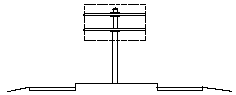
 | Des. 2 | 1525
 | Des. 3 | 2350
 | Des. 4 | 4200
 | Des. 5 | 4500

