Weight of Overhead Supports - Butterfly

Sign Support Type |  | Total Wt. of One Set of Arms, lbs. | Total Wt. of Two Sets of Arms, lbs. | Configuration
10.48 | Des. 1 | 1825 | 2150 | 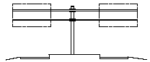
 | Des. 2 | 1975 | 2500
 | Des. 3 | 2325 | 2800
 | Des. 4 | 2450 | 3000
 | Des. 5 | 3925 | 5000
 | Des. 6 | 3650 | 4400
 | Des. 7 | 4125 | 5400
 | Des. 8 | 5050 | 6700
 | Des. 9 | 5750 | 8000

