Weight of Overhead Supports - Structure Mounted

Sign Support Type |  | Total Wt. of Support, lbs. | Configuration
TC-18.24 |  | Almost all the weight is involved in the sign; approximately 400 lbs. for a support with 10 x 10 foot extrusheet sign, including lights. | 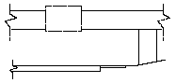
TC-18.26 | Des. 1 | 150 | 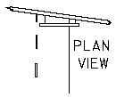
 | Des. 2 | 200
 | Des. 3 | 325
 | Des. 4 | 600
 | Des. 5 | 175
 | Des. 6 | 225
 | Des. 7 | 400
 | Des. 8 | 175
 | Des. 9 | 300
 | Des. 10 | 325

